CMS

Release Notes

Version 6.2

Revision History
Date | Version | Description | Author
30/05/2017 | 6.2 | General Update | Sally White

Table of Contents
CMS Desktop 4
1. Release Notes 4
2. Security 4
i. PIN Pad Login 4
ii. User Profile Hierarchy 6
iii. Changes to User Profiles 6
3. About Me 7
4. Home Specific Options 7
i. Overview 7
ii. System Options 8
5. Contacts 9
i. Primary Next of Kin 9
6. Status Flags & Banner 9
7. Employees 10
i. Archiving Employees 10
ii. Display Employee NOK 10
iii.Postcode 10
8. Diary 11
9. DOLs 11
10. System Options 11
i. Accidents & Incidents – Default Review Dates 11
ii. Disable links to MCA 12
iii. Daily Care Subject Selection 12
iv. Enabling PINS 12
v. Changing User PIN 12
11. Policies & Procedures 12
i. New options to import/export policies 12
ii. Read Request Report 13
iii. Setting the Home Scope (Multiple homes only) 14
12. Reports 14
13. Bug Fixes 15
CMS Touch 16
1. Login Pins 16
CMS Tablet 17
1. Login Pins 17

CMS Desktop

Release Notes
In between major releases of CMS we often release interim updates to accommodate small changes and bug fixes. These updates are optional and you can download them at any time by going to the Tools menu and selecting Check for Updates.
We do not send out newsletters or issue release notes for these small updates but our customers have asked us to make release notes available to be able to see what changes have been made and when. You can access this area, by selecting Release Notes from the help menu within CMS.

Security
There have been a number of changes to the security module. We have tightened some of the security settings as well as adding some new features

PIN Pad Login
We have introduced the option to allow users to log in with a PIN Pad when using either CMS Touch or CMS Tablet. As a PIN cannot be as secure as a password, you will still need to use a user name and password to log into the main CMS Desktop.

The PINs are 4 digits and should considerably speed up the time taken to log in to both CMS Touch and CMS Tablet

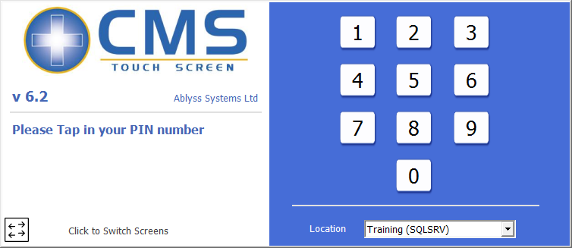  Figure 1 - CMs Touch | 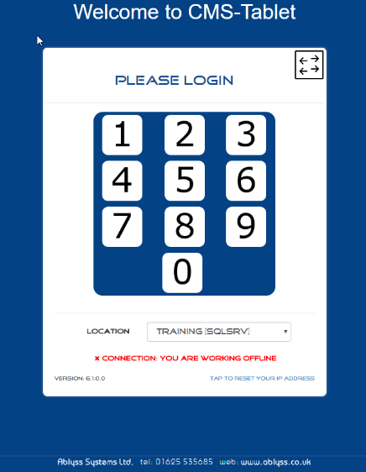  Figure 2 - CMS Tablet

The Switch button will allow you switch back to the standard log in if required.

To enable PINs your system administrator will need to access the Settings screen from the tools menu within CMS

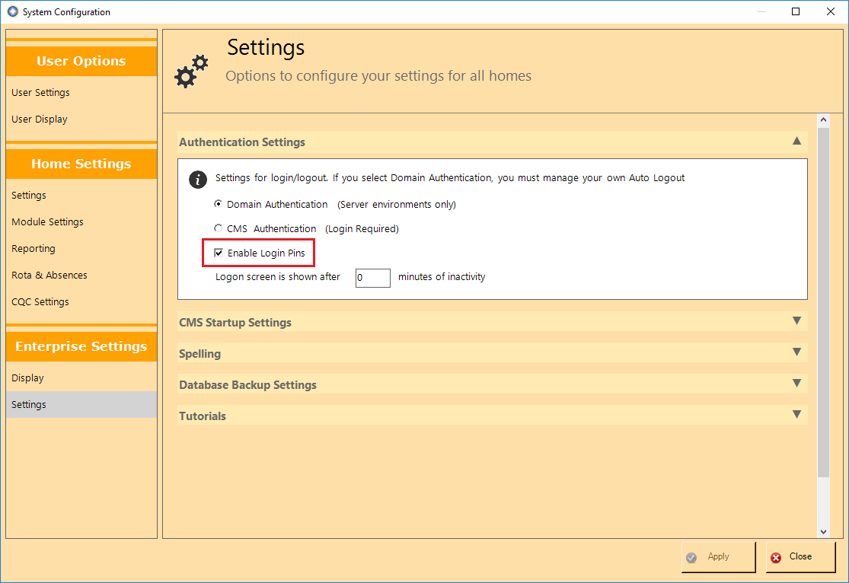
Figure 3 - Enabling PINs

If you have enabled PINs you will find that the security module has changed to adapt this. Users can also change their own PIN number from within User Settings

Adding and Editing Users
You can manage users individual Login PINs by going to Admin -> Security -> Users You can then enter a Login PIN or remove a Login PIN for users. The Login Pins have to be 4 numbers long and no two users can have the same Login Pin. You can choose to type in your own PIN – or you can type in 1 or more numbers and the PIN will be automatically generated for you. In the below example, 55 was entered into the PIN. When this record was saved a unique 4 digit PIN was created starting with the number 55.

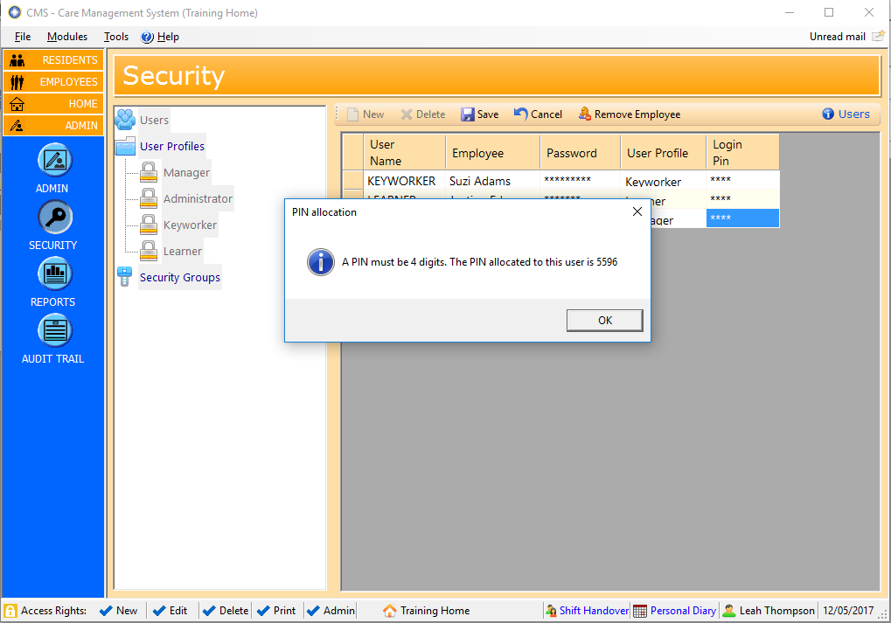
Figure 4 - setting a PIN for your users
Login Pins will work with both normal and windows authentication.

User Profile Hierarchy
The user profiles now have a hierarchy. That means you can only make changes to other users who belong to profiles on the same level or lower than yours. For example in the set up below, a user with a ‘Manager’ profile may change the security settings for any users that have a Manager, Administrator, Keyworker or Learner profile but they may not makes changes to users with a Super User profile. (Please note the user must still have access to the Security module in the first place to make changes). The purpose of the hierarchy system is to give your staff the flexibility to be able to create and edit users whilst still being able to prevent them from elevating their access levels.

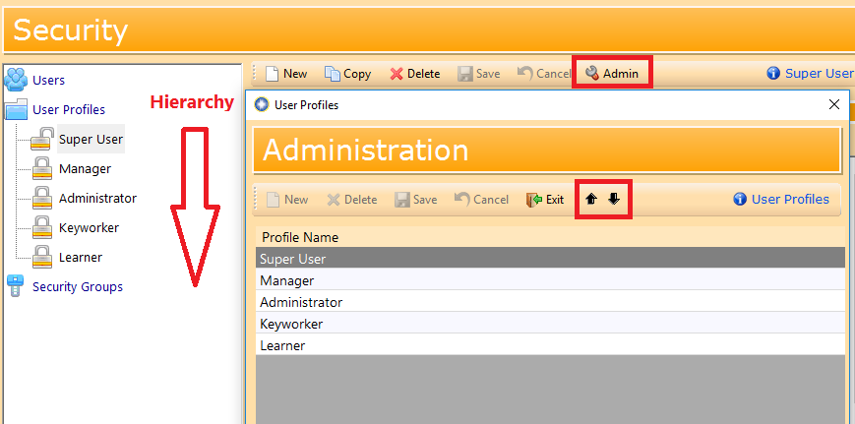
Figure 5 - Setting Profile Hierarchy
CMS will create the initial hierarchy using the existing level of permissions of each profile. After that you can change the order by yourself, clicking on ‘Admin’ then moving the profiles up or down. Users who have the System Admin setting enabled on their user profile will be able to change any user profile.

Changes to User Profiles
A new permission level has been added called Distribution Groups

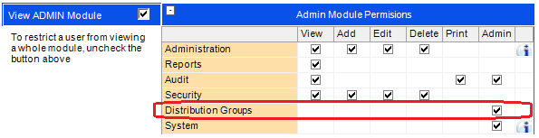
Figure 6 - Setting permissions for creating Public Message Groups

In a previous release we introduced Message Distribution Groups which allow you to assign key personnel to particular groups making messaging a much quicker process. In order to be able to create a public group (one available for all staff to use) you were required to have System Admin rights. From feedback from customers we realize that this has been too restrictive which is why we have introduced the new security setting.

About Me
The ‘About Me’ module now supports multiple assessments. Click on the Admin option to Add/Remove assessments or manage existing assessments. The example below shows 3 different assessments in the ‘About Me’ module.

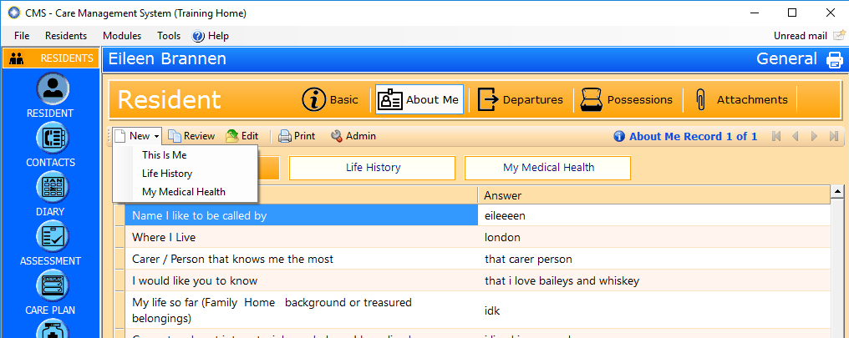
Figure 7 - Multiple About Me Assessments

Home Specific Options

Overview
For environments where the same CMS Database is used for multiple Care Homes there are now options to make settings applicable to only specific homes or for all homes within your group. The functionality is available in
- System Settings
- Lookups (e.g. Religion, Body Map conditions, A & I categories)
- Vital Categories
- Assessments
- Care Plan Templates
- Risk Assessment Templates
- Policies

In each of the above sections you will be able to set the home scope either by clicking on the Home Scope button or, when viewing a grid, clicking on the link. Please note you will only see these options if you have multiple home set up.

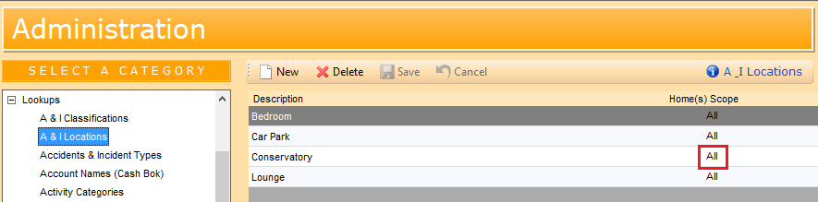
Figure 8 - Setting Home Scope from a grid view

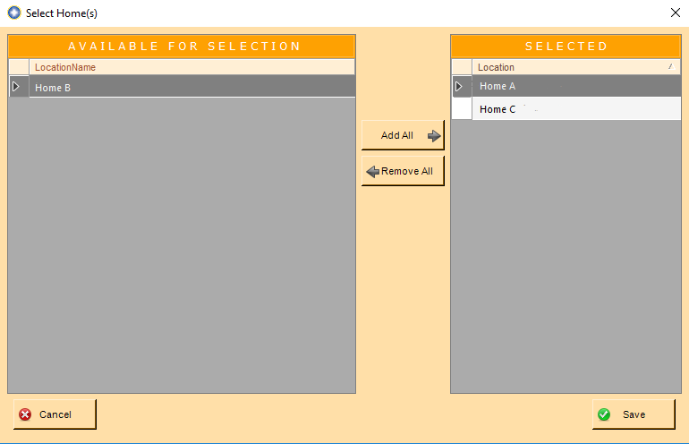
Figure 9 - Selecting Homes
In the Above example we clicked on the Home Scope link for the ‘Conservatory’ option for Accident and Incident Locations. We only want this option to appear in homes A & C. when the record is updated the unique IDs for homes A and C will be displayed on the grid

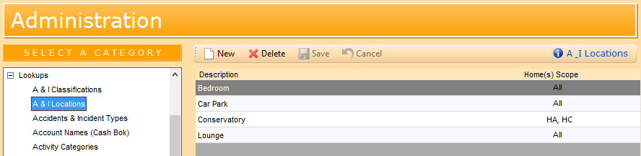
Figure 10 - A lookup entry where the scope has been set

System Options
The system options has now been divided into 3 sections: User Options, Home Settings and Enterprise Settings. This is to help indicate where the Home Scope setting can be applied
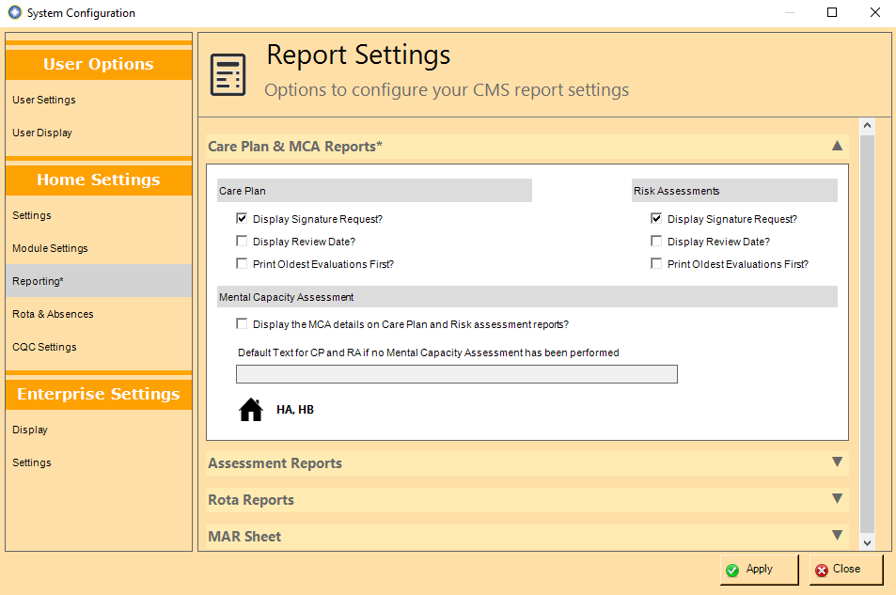
Figure 11 - Setting Home scope in System Options
In the example above, the Report Settings have been changed from ‘All Homes’ to homes ‘HA, HB’. In this case the home with Location ID of ‘HC’ was not included and continued with the previous setting.

Contacts

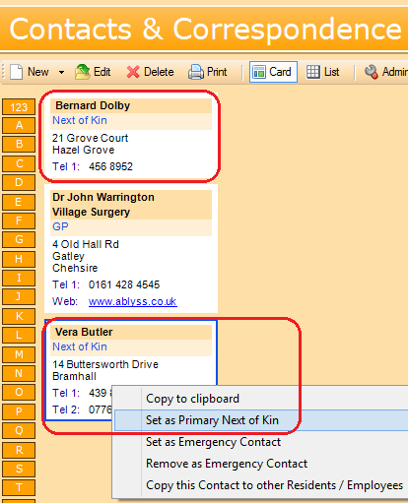
Primary Next of Kin
Figure 12 - Setting NOK
Sometimes a resident or an employee’s next of kin will change. Previously this required you to edit the resident or employee record and change the NOK details within that wizard. We have now simplified the process by allowing you to right-click on an alternative next of kin and assigning the contact from the menu

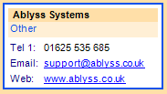
iii. Website

When adding a contact you are now able to enter a website. When looking at the contacts you can click the link and it will go straight to the website.
The CMS Touch will also display the website with the ability to click the address and view on the internet.

Status Flags & Banner
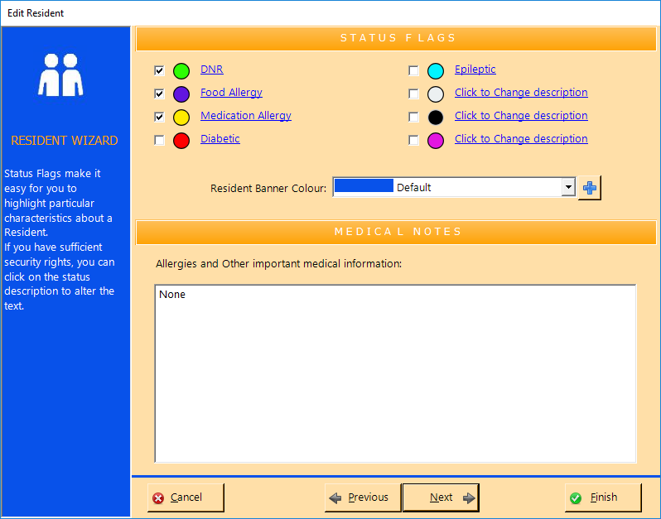
Residents
Figure 13 - setting Status flags for Residents
We have increased the number of resident status flags by 3, allowing for a total of 8. If you have System Admin rights you can rename these flags. Please bear in mind that that if you change the flag you are changing it for all residents within your home. CMS Touch has also been updated to display these new flags.

Employees
We have also introduced status flags to the employee’s module. We have limited this to 3 flags. Another addition we have made is the ability to change the employee’s banner colour as you can with the residents. To access either of these changes edit an Employee’s record and navigate your way through to the status flag screen. If you have system Admin rights you will be able to change the flags’ descriptions. Please bear in mind that that if you change the flag you are changing it for all employees within your home.

Employees

Archiving Employees
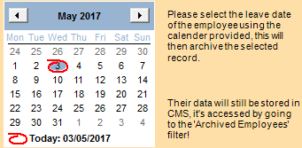
Figure 14 - Archiving an employee
We have introduced a quicker way to archive an employee. In the toolbar you will now see an Archive button. Clicking this will open a date selector allowing you to set the date the employee left your home. Once a date has been selected, CMS will automatically archive the employee.

Display Employee NOK

On the employee’s basic screen you can now choose to display the employees NOK contact details or the Employee’s address with an option to switch between the two. To set the default go to Tools > Settings > Module Settings & in Employee Settings you can see Default displayed employee address.

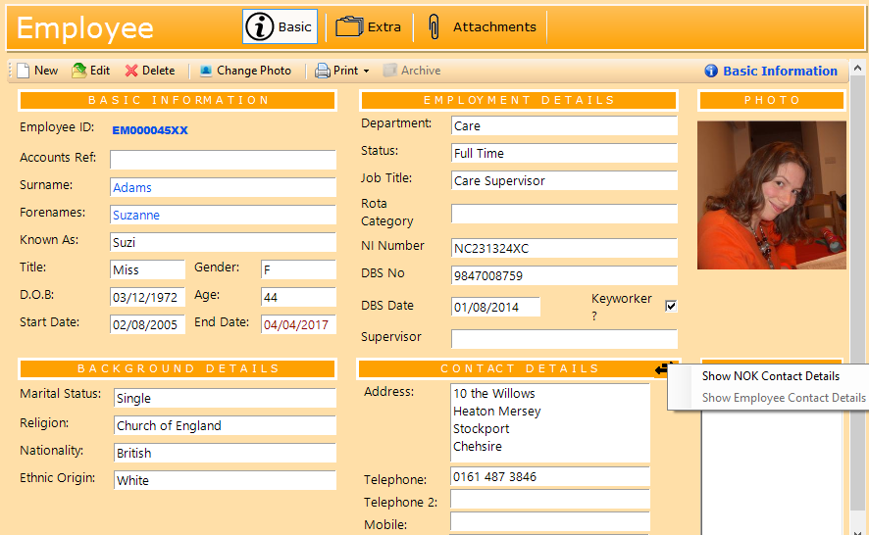
Figure 15 - toggling an employee's address

Postcode
You can now add a postcode o the employee’s address

Diary
When viewing the home diary you now have the ability to be able to filter the information on your resident filters
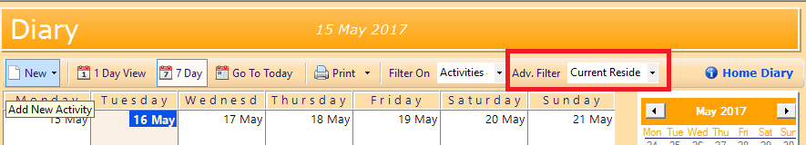
Figure 16 - filtering the Diary

DOLs
- When adding or editing a case within the DOLs section you can now record the reason for the DOL
- The Case Overview will now display the DOL start date

System Options
We have added the following new features to the System Options. If you have System Admin rights the System Options can be accessed by clicking on the Tools menu then on Settings.

Accidents & Incidents – Default Review Dates
At the end of the A&I wizard, you have the option to insert review dates prompting you to record follow up notes for the incident record. In the past this has relied on the user remembering to add reminders. You can now pre-populated this section with the new option available from the system Settings. In the example below, all A&I incidents will be pre-populated with review dates shown.

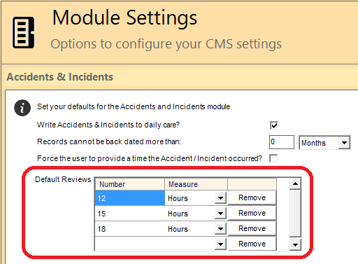
Figure 17 - Setting default review periods for A & I

Disable links to MCA
We have added the option to disable the ability to link MCA assessments to Care plans / Risk assessments. This feature can be accessed from Module Settings >> Care Plans & Risk Assessments. This is feature is not enabled by default

Daily Care Subject Selection
We have added in the option to stop users from changing the subject when adding a daily care note. This feature has been added to help improve the filtering of daily care notes. This setting can be accessed from Module Settings >> Daily Care. This is feature is not enabled by default.

Enabling PINS
(see PIN pad login earlier at the start of the document)

Changing User PIN
A user can change their own PIN number by selecting User Options >> User Settings >> Change PIN

Policies & Procedures

New options to import/export policies
Prior to this version, CMS only allowed you to import/export Policies’ data. There are now 2 new options that include both the data and the actual documents.
We have added a new feature to help simplify the initial import and export of policies into CMS. This has been based around the GMP Systems documentation but it should also simplify policy imports in general.

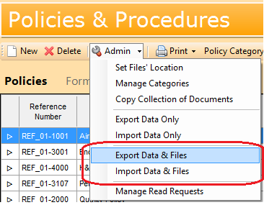
Figure 18 - Exporting & Importing Policy Documents

When you add polices to CMS, firstly select the folder in which your policies reside. If your policies exist within subfolders (like in the example below) corresponding categories will be created for each of your policies.
In the example below, if we select ‘My Original Policies’ as the folder to import, categories will be created for:
- Business Management
- Continuous Quality Improvement
- Health & Safety Management
- Looking after the Service User
All files found within these folders will then be imported into its respective category.

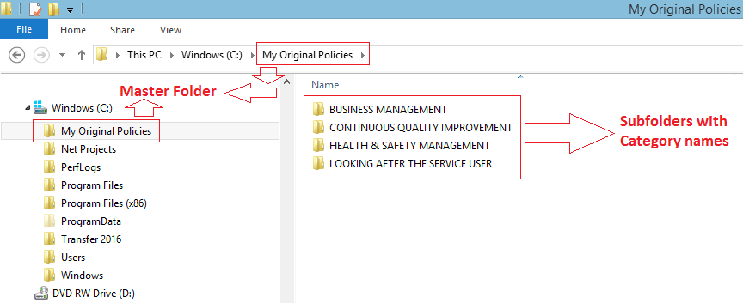
Figure 19 - importing Policy Documents

In order for CMS to import the files, ideally your policies should be named using one of the following formats:
- “Policy 01-1000 - Statement of Purpose.doc”
This format is how the GMP Policies files are normally named and is formatted as follows:
‘Policy’ Document type
’01-1000’ Reference No
‘Statement of Purpose’ Description

- “F__REF_01-2-205__Complaints.docx”
This is the format that CMS adopts and is constructed as follows:
‘F’ Document Type (F (form) or P (policy))
‘REF_01-2-205’ Reference No
‘Complaints’ Description.

- “F__REF_01-2-205__Complaints__EM000001XX__2018-05-03.docx”
This more detailed format is used when exporting the files:
‘F’ Document Type (F (form) or P (policy))
‘REF_01-2-205’ Reference No
‘Complaints’ Description
' EM000001XX’ Unique EmployeeID that represents the reviewer of the policy
‘2018-05-03’ The policy review date

*** Even if your documents are not named in any of the formats above, you can still use the import functionality. CMS will use the file name as the Description of the document.

Read Request Report
A new report has been created to show which employees have read each of your policies.

Setting the Home Scope (Multiple homes only)
Even though this is not a new feature, it’s worth mentioning the option to set Policies & Procedures apart for different homes. If you click on ‘Admin’ then ‘Set Files’ Location’ you’ll see the pop up option to make Policies home specific. You also have the option to copy the collection of policies to another home in the same CMS Database by clicking on ‘Copy Collection of Documents’.

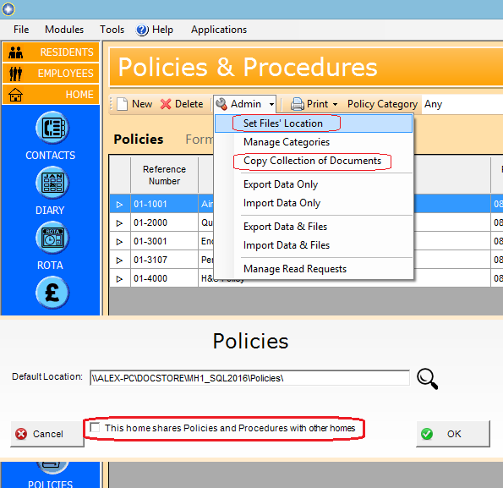
Figure 20 - Setting Scope for Multiple Homes

Reports
The following additional reports have been added to the system:
- Vitals – you can now print an overview of vitals for all of your residents based on the selected category
- MAR Sheet – the spacing has been increased to allow for 2 signatures
- Resident & Employee Photo Reports (accessible from the Resident’s / employee’s basic details)

Bug Fixes

- Policies – When deleting a Policy entry, the documents weren’t being deleted in the process.
- This is me Now displays whether the user does not have permission to save an about me assessment correctly.
- When looking at a resident’s next of kin details on the resident basic screen the ‘View on map’ button will now display the location.
- Fixed the right click menu when looking at attachments throughout the system.
- Ability to add Employee’s postcode when entering a new employee’s details.
- User Defined Questions – the $$ feature in the template section did not work
- When adding a review from the diary - shows confirmation required checkbox? This is only available in the Employee Review section.
- View on Map’ button on the Resident main page searches for the name of the NOK instead of just address. The button should also not work when field is empty.
- Log book default category does not work when adding a new log book record.
- When you press the print button, print options opens – if you press the x instead of cancel the print dialog opens.
- Shift Handover – Breakdown you can now order the columns
- Body Map – when you select a body map entry numbered anything other than 1 and then click ‘Show Condition history’ CMS renumbers it to 1
- MCA Report question “Why the resident lacked capacity” has now the correct description has been moved to the bottom.

CMS Touch

Login PINs
Login Pins have been added for the CMS Touch, They will allow the user to enter a unique 4 digit login pin rather than logging in with the usual username/password combination. You can setup and manage Login Pins on the CMS Desktop application.

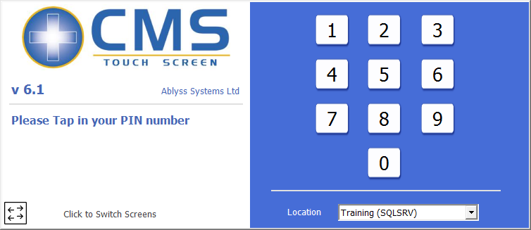

CMS Tablet

Login PINs
Login Pins have been added to the CMS Tablet, They will allow the user to enter a unique 4 digit login pin rather than logging in with the usual username/password combination. You can setup and manage Login Pins on the CMS Desktop application. On the tablet if you have failed to enter a PIN successfully after 3 attempts, you will be locked out for 1 minute.

