|  |
| --- |
| CMS  Release 7.1 |

|  |
| --- |
| Ablyss Systems  Email: support@ablyss.co.uk  Website: www.ablyss.co.uk |

|  |  |
| --- | --- |
| Ablyss Care Management System Release Notes  March 2019 |  |



Release Overview 3

Mental Capacity Act Assessment Redesign 4

Setting up the MCA Assessment 5

Changes to MCA List Form 7

Attachments 8

Care Plan and Risk Assessment Read Requests 9

Creating a Read Request 9

Viewing a Read Request 11

Read Request Report 12

Manage Read Requests 12

Emotion Mapping 13

Tablet Offline Assessments 14

Tablet Viewing Policies 16

Accessible Information Standard (AIS) Disability Signs 17

Accidents and Incidents 18

Creating Daily Care Notes When Updating Existing A&I 18

Reported and Logged By 18

A&I Category Associations 19

Employee Absences 20

1. Absence Type Changes 20

2. Private Absences 20

3. Bradford Factor 21

Report Changes 23

Specific Resident Reporting 23

1. Residents / Employees List View 23

2. Vitals Overview Report 24

3. Accidents & Incidents - Date Range Filter 24

4. Employee Absences - Filtered Report 25

5. Training Matrix Colours 25

6. Assessment Scores Matrix 26

7. Custom Assessments 26

8. About Me - Matrix Reports 26

9. Resident Cashbook Balances 26

CMS Desktop Changes 27

1. Scored Assessment – Display Previous Action 27

2. Resident’s Medical History 27

3. Contacts – Additional Information and Labelling 28

4. Correspondence Email Attachments 28

5. Daily Notes – Attachment Notification Display 28

6. Diary - Security Groups 28

7. Diary – Legend Select Memory 28

8. Filters – NOT Function 28

9. Resident / Employee – Report Packs 29

10. Vitals View – Colour Coded 29

CMS Tablet App Changes 30

1. Birthdays 30

2. Sorting 31

3. Daily Care Filters 32

4. AIS Signs 33

5. Care Plan / Risk Assessment Previous Evaluations 34

6. Daily Care Emotion Mapping 35

7. Read Requests 36

|  |
| --- |
| Release Overview Release 7.1 sees a lot of user requests added to the CMS system. The major enhancement to the system is the Mental Capacity Assessment redesign.  We introduced the MCAs 10 years ago in version 3 of CMS. This was in response to changes to the Mental Capacity Act. The MCAs have evolved over the last 10 years and it is clear from customer feedback that the current format is too restrictive so we redeveloped this module to provide you with greater flexibility.  We have also introduced the ability to send read requests for Care Plan and Risk Assessments. Changes to the CMS tablets ensures that staff can read requested documents without the need to log onto the CMS Desktop.  The release comprises of the following: -   * MCA Redesign * Care Plan and Risk Assessment Read Requests * Emotion Mapping * Tablet Offline Assessments * Tablet Viewing Policies * Accessible Information Standard (AIS) Disability Signs * Accidents and Incidents * Minor Enhancements   + Reports   + Desktop   + Touch   + Tablet |

## Mental Capacity Act Assessment Redesign

We introduced the first MCA 10 years ago in response to changes to the Mental Capacity Act. The MCAs have evolved over the last 10 years and it is clear from customer feedback that the current format is too restrictive, so we redeveloped this module to provide you with greater flexibility.

|  |  |
| --- | --- |
|  | Key Points |
| * The new MCA format makes use of custom assessments allowing you to design your own questions and answers. * All new MCAs will be recorded in the new format * MCAs in the old format cannot be automatically updated to the new format * You will not be able to edit any MCAs in the old format. You will need to upgrade them to the new format | |

### Setting up the MCA Assessment

The previous version of the MCA assessment assumes the resident already lacks capacity therefore only requires you to fill in the Problems & Best Interests. The new version will give you the option to state whether the resident does in fact lack capacity and detail your findings before needing to fill out the full assessment. This is known as ‘Stage 1’.

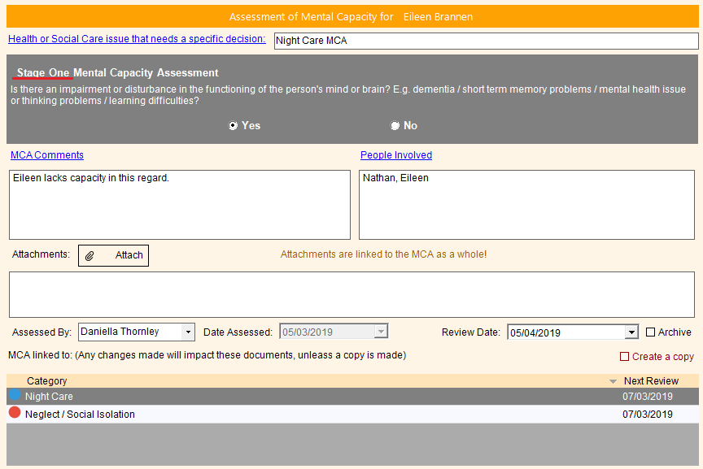

This will allow you to document that a resident doesn’t lack capacity but will show that you have assessed their capacity.

If the resident is found to lack capacity you have the ability to set up your own MCA assessment. Using the Assessment wizard, you can add your own questions & answers allowing you to satisfy the needs of the resident, CQC and your local borough. To access the MCA wizard, go to ‘Tools > Assessments > MCA Assessments’ and you will be taken straight to the MCA assessment.

When you enter an MCA for a resident that does lack capacity you will be prompted to fill out the MCA assessment filled out in the step above. This will be known as ‘Stage 2’. All of the previous MCA’s in CMS will be considered Stage 2.

If an MCA has been linked to either a Care Plan or Risk Assessment it will be clearly visible and colour coded dependant on whether or not the resident lacks capacity.

|  |  |
| --- | --- |
|  | When Grey the resident does NOT lack capacity. |
|  | When Green the resident DOES lack capacity. |
|  | When Blue the resident DOES lack capacity and the MCA is saved in the old format. Ideally when they are due for review you should convert them to the new MCA format. |

If you complete an MCA for either a Care Plan or Risk Assessment, you can create one from scratch or link it to an existing one. If you are linking an existing MCA you will be given an option to create a copy of an already existing MCA or link to an existing. These are to be used as follows:

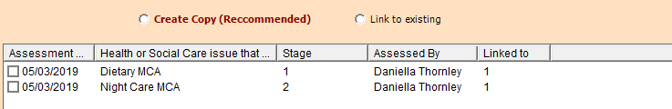

* Creating a copy: will copy the MCA entirely, any changes you make will not affect the original in any way. This is the recommended way of linking to ensure that no data is lost.
* Link to existing: Will link directly to another MCA any changes you make will also be made to any other linked MCA’s. This is how MCA linking worked in previous versions

You can see in the grid above how many records the MCA is linked to. When editing an MCA, you can see exactly which records you will be affecting. Care Plans will be indicated with a blue marker, Risk assessments, red:

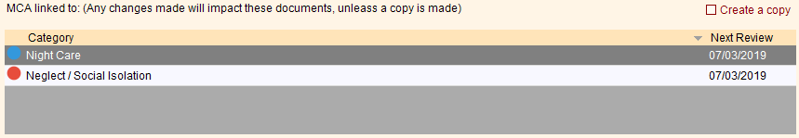

When you open to view an MCA that is linked to one or more records you are given the following options:

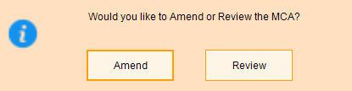

Amend will update the current MCA whereas review will create a historical entry allowing you to view how it has changed over time.

### Changes to MCA List Form

We have changed the MCA form so that you can easily keep track of residents current MCA assessments. This screen has been split into 2 and will work the same way that the Custom Assessments do. The top grid shows the most recent active MCA Assessments. If the document has been linked to any Care Plans or Risk Assessments this will also be indicated. By default, only active MCAs will be shown but you can also show historic ones.

The bottom grid displays each review for the MCA highlighted, allowing you to go back and view how the MCA has changed over time. Simply double click on a record in the previous reviews grid to open the MCA on screen.

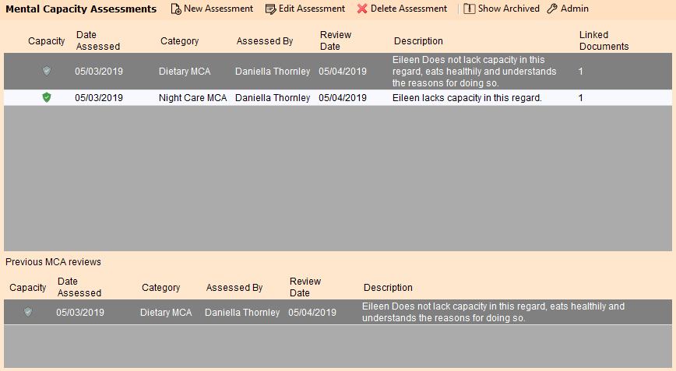

Any MCA’s that have been completed on the old format (indicated with the blue shield) will need to be updated to the new format. To help with this transition we have added a button at the bottom of the old MCA form: ‘Convert to new format’. This will open the new MCA format with as much detail as possible filled. This will mean you will have to fill in the MCA assessment. We have left in the ability to copy and paste from the old MCA format to help speed up this process. The old MCA will then be archived off, over time migrating you to the updated MCA’s.

### Attachments

We have kept the ability to add in attachments to an MCA allowing you to link any relevant documents at the MCA’s top level for easy access and storage. Simply click Attach when viewing the MCA to add new attachments. Right clicking on the attachments grid will allow you to use copy, paste, delete, properties functions as available on other attachments in CMS.

## Care Plan and Risk Assessment Read Requests

We have introduced a read request system, which works in a similar fashion to the policy read requests. Read Requests are a great way to notify staff members when changes to care plans or risk assessments have been made. Please note whilst we will refer solely to care plans in these release notes, this functionality is also available for risk assessments

|  |  |
| --- | --- |
|  | Key Points |
| * Requests can be made only on CMS Desktop either when creating or reviewing a care plan * Requests are sent as a message which can be viewed on either CMS Desktop, CMS Touch or CMS Tablet. * Users must confirm that they have read the care plan otherwise the message will stay active. Unlike policies the time spent reading a care plan is not recorded only a declaration of the fact is logged. * Full reporting to show which of your staff have read the care plan | |

### Creating a Read Request

Once a read request has been created, a new message will be created which you can forward on to your employees. A read request can be created in one of 3 ways

|  |  |
| --- | --- |
| Creating Read Request 1 | **Option 1**  From the main care plan screen.  The read request will be for the active care plan. |
| Creating Read Request 2 | **Option 2**  From the care plan creation or edit screen.  This is particularly useful when creating a new care plan. A new request will be created when you save the care plan |
| Creating Read Request 3 | Option 3  From the care plan evaluation screen.  This is particularly useful if you have made changes to the care plan and need to notify staff. A new request will be created when you save the evaluation |

### Viewing a Read Request

Once a request has been made, the user will be notified either though the messaging system or when viewing the individual care plan

|  |  |  |  |  |  |
| --- | --- | --- | --- | --- | --- |
| Viewing a Read Request 1 | *Messaging*  Click the highlighted link to view the care plan and to confirm that you have read the document.   |  |  | | --- | --- | |  | Good to Know | | If you do not confirm that you have read the document, the message will not be marked as read. | | |
| Viewing a Read Request 2 | *Care Plan View*  Once you have read the care plan click the ‘Confirm Reading’ button.  If a request has been issued for a care plan you will also see the  button when viewing an individual care plan either from   * Main screen * Creating / Edit screen * Evaluation screen |

If you use either CMS Touch or CMS Tablet you will be notified about a read request in the same way:

* Messaging system
* Viewing an individual care plan

### Read Request Report

Once a read request has been issued you can access the Read Reports screen from the Request Menu in the main CMS Desktop (see fig Creating Read Request 1)

|  |  |
| --- | --- |
|  | This will provide you with an overview for all staff and a breakdown for an individual read request. |

### Manage Read Requests

This feature is also accessible from the Request Menu in main CMS Desktop (see fig Creating Read Request 1)

|  |  |
| --- | --- |
|  | Here you can see what requests have been issued against individual employees for:   * Care Plans * Risk Assessments * Policies |

## Emotion Mapping

The emotion mapping can be recorded on desktop, touch and tablet via when recording the daily care notes or touch assessments.

* This feature can be turned off
* The terminology can be changed
* Can set to mandatory or optional
* Graphic analysis of emotions
* Emotions can be customised
* Capture can be either as a colour (Plutchik’s Wheel of Emotions) or Emoji (familiar facial expression)
* Graphical Analysis of emotions in shift handover observations breakdown
* Visible at shift handover observations

|  |  |  |  |  |  |
| --- | --- | --- | --- | --- | --- |
| Unknown | 0 |  | Tearful | 5 |  |
| Joyful | 1 |  | Worried | 6 |  |
| Happy | 2 |  | Annoyed | 7 |  |
| Content | 3 |  | Fearful | 8 |  |
| Sad | 4 |  | Angry | 9 |  |

## Tablet Offline Assessments

We have now added the ability to complete custom assessments on the tablet either offline or online. When viewing a resident’s assessments, you will now see a plus button in the bottom right corner. Tapping on this will bring up a menu for you to either review the assessment you are looking at or to add a new assessment.

|  |  |
| --- | --- |
|  | When viewing a resident’s assessments, you will now see a plus button in the bottom right corner. |
|  | Tapping on this will bring up a menu for you to either review the current assessment or to add a new assessment. |
|  | If adding a new assessment, select the assessment model from the list. |
|  |  |

|  |  |
| --- | --- |
|  | If you are reviewing, the assessment you will be automatically loaded |
|  |  |

Upon saving, a note will also be written into the resident’s daily care notes as it would if you had done the assessment within CMS Desktop.

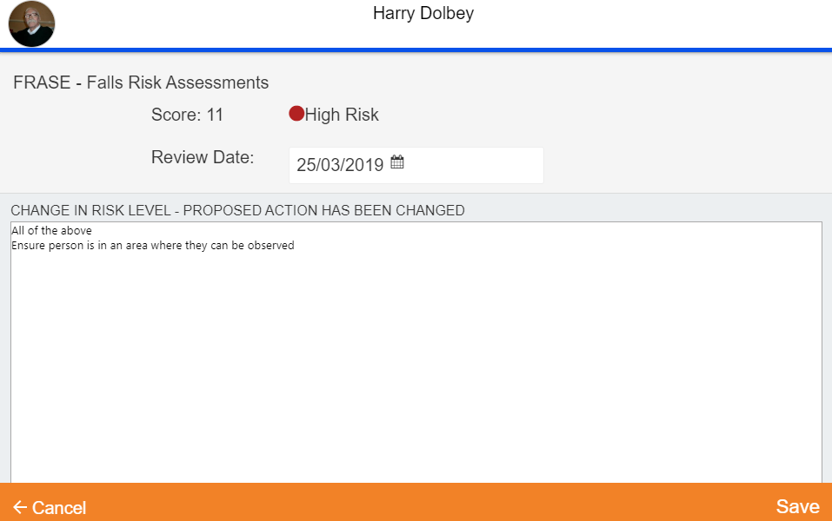

## Tablet Viewing Policies

A user can open a policy if a request has been made.

* A request can be made to review a policy through the main CMS Desktop
* A link will be displayed on the message. Clicking the link will download the policy and mark the policy as read. The user must be online to download the policy

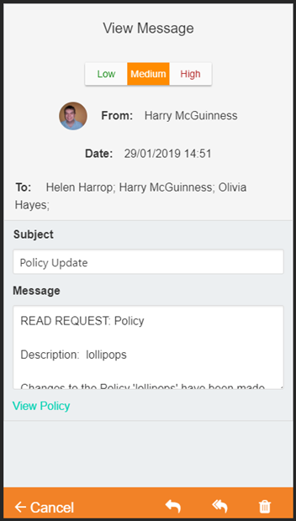

## Accessible Information Standard (AIS) Disability Signs

AIS directs and defines a specific, consistent approach to identifying, recording, flagging, sharing and meeting the information and communication support needs of patients, service users, carers and parents with a disability, impairment or sensory loss.

|  |  |  |  |
| --- | --- | --- | --- |
|  | Dementia | [C:\Users\alistair.COLVILLECARE\AppData\Local\Microsoft\Windows\INetCache\Content.MSO\2B6906C.tmp](https://www.google.com/imgres?imgurl=https://www.energize.uk.net/images/Blind%20or%20Partially%20Sighted.jpg&imgrefurl=https://www.energize.uk.net/training-articles/blindpartiallysighted&docid=mVsYQIJ1Em0QAM&tbnid=pdg4mx7W0_NRZM:&vet=10ahUKEwiptYCriOXdAhWKKcAKHcB8BfAQMwg2KAIwAg..i&w=1421&h=1200&bih=967&biw=1920&q=partially%20blind%20symbol&ved=0ahUKEwiptYCriOXdAhWKKcAKHcB8BfAQMwg2KAIwAg&iact=mrc&uact=8) | Vision Impaired |
| See the source image | Hearing Loss | [Image result for visually impaired icon](https://www.google.com/url?sa=i&rct=j&q=&esrc=s&source=images&cd=&cad=rja&uact=8&ved=2ahUKEwiexdzKh7XcAhVD3aQKHU0uBSYQjRx6BAgBEAU&url=https://thenounproject.com/term/blind/5030/&psig=AOvVaw1Wzt6Hj5tbHJKsJ-3I07UK&ust=1532429600675858) | Registered Blind |
| [Image result for speech bubble icon](https://www.google.com/imgres?imgurl=https://www.psdicons.net/wp-content/uploads/2013/08/speech-bubble-2-psd-png.jpg&imgrefurl=https://www.psdicons.net/speech-bubble-icon-2-psd-png/&docid=9Cz45_eDN2DNKM&tbnid=_qtOuquTqKqyKM:&vet=12ahUKEwiKkOWqiLXcAhVONOwKHVsMA9w4yAEQMygTMBN6BAgBEBQ..i&w=600&h=300&bih=794&biw=1582&q=speech%20bubble%20icon&ved=2ahUKEwiKkOWqiLXcAhVONOwKHVsMA9w4yAEQMygTMBN6BAgBEBQ&iact=mrc&uact=8) | Speech Difficulties | See the source image | Autism |

* Recording of the disability sign against a resident
* These signs will be visible in the banner section on the CMS desktop, touch & tablet systems
* These signs will be printed on all resident specific reports

## Accidents and Incidents

|  |  |
| --- | --- |
|  | Key Points |
| * Capture of Reported By & Logged By information * Categories are now linked to a specific Report Type * Daily Care Note will include action taken * Daily Care Note will reflect any changes to the A&I details | |

### Creating Daily Care Notes When Updating Existing A&I

CMS currently gives you an option when initially creating an A&I to ask whether you want to create a copy in the resident’s daily care notes. We have now added in the same feature when editing an existing Accident and Incident either through the wizard or on the A&I page itself. The note will then display Incident details, Action taken and follow-up note as well as stating which fields had been edited.

### Reported and Logged By

CMS will now display who logged and also who reported the note on the front screen. The person logging the note will be the logged in user who created the A&I, with ‘reported by’ being selected from a drop-down list.

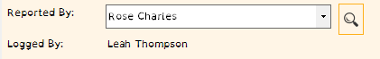 The logged by cannot be changed as it is who originally created the A&I

### A&I Category Associations

When creating an A&I CMS allows you to specify whether it is an Accident/incident/Other. It also allows you to select a category, i.e. Fire, fall, injury, theft etc. For reporting purposes, we have enabled the ability to split categories across the type of A&I being created. For example, the ‘Theft’ category should really belong in the ‘Incident’ type rather than ‘Accident type.

Once you have set up and paired your categories with the incident types you can lock the Incident type & Category so that staff cannot type into the selection boxes. This will help with A&I reporting as the descriptions will all be unified across the home/homes.

## Employee Absences

### Absence Type Changes

We have added a couple of true/false options when adding new absence types from CMS. These are:

* Confidential – This has been added to allow the ability to hide an employee absence from the home diary, for example, somebody may be off on compassionate leave for a private matter you can hide this on the shift handover.
* Bradford Scored – Any absence types with this checked will show on the sick leave panel. Any absences under one of these types will be included in the Bradford calculation.

This is the new admin panel for absence types with the new columns highlighted!



### Private Absences

It has been requested if the home diary could stop displaying certain absences. We have added a “Confidential” flag so that you may state which types of absence you wish to hide from staff on the home diary screen. People who have access to ‘Employees > Absences’ Will be able to view them but only in the Absences module of CMS.

We have also changed the way that CMS displays absences. Previously if you couldn’t see the employee’s records due to security groups you also couldn’t see their absences on the dairy, we have removed this limitation so that everyone can see whether staff are absent, if you do want to hide some absences we suggest using the new feature which will allow you to keep them private from all staff.

### Bradford Factor

We have added the ability to record employee’s Bradford Factor scores. This formula allows companies to apply a relative weighting to employee unplanned absences (sickness, Doctors appointments, emergency childcare, etc). The Bradford Factor supports the principal that repeat absences have a greater operational impact than long term sick. It is devised from using the Bradford Formula S2 x D = B using data only from the past year.

* S is the total number of separate absences by an individual
* D is the total number of days of absence of that individual
* B is the Bradford Factor score  
  For more information on the Bradford Factor please read here: <https://www.bradfordfactorcalculator.com/>

When looking at absences we have added a button at the top ‘Sick Leave’, this will filter the absences down to those that are flagged as ‘Bradford Scored’. CMS will then work out the Bradford score using the formula above.

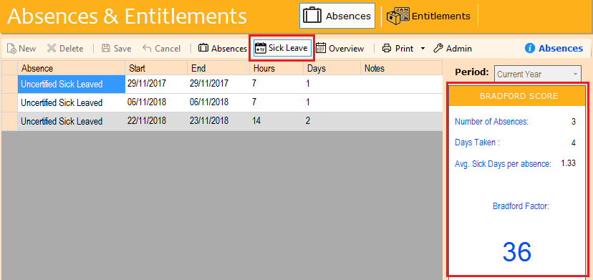

We have added Bradford Factor reports so that you can print off an individual or the whole homes Bradford Scores as shown in the picture below. Both reports can be found under the print menu in the toolbar.

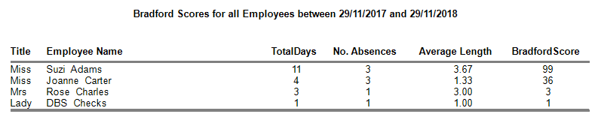

## Report Changes

We have made some changes to the following reports, this is to ensure that we are keeping them in line with the requirements that CQC is expecting from care home reporting.

### Specific Resident Reporting

The banner of all individual reports will be standardised to display the resident’s photo and AIS information. This will be for both landscape and portrait orientation.

### Residents / Employees List View

We have added the ability for the report to include resident flags when printing both the residents and the employee’s lists, you will have a key at the bottom of the report for each flag.

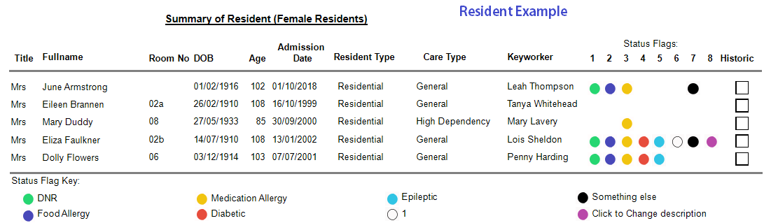

### Vitals Overview Report

If you have linked a custom assessment to a vital, it will now be displayed on the report next to the relevant vital as it is displayed on the overview grid.

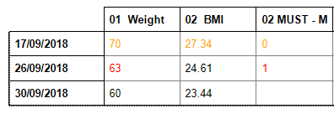

### Accidents & Incidents - Date Range Filter

Currently you can only filter A&I’s by date if you are in the A&I module in CMS, we have added the option to filter through

Admin > Reports > (Residents/Employees/Management) > Accidents& Incidents.

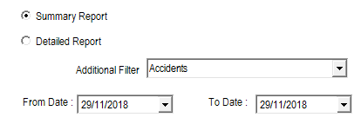

### Employee Absences - Filtered Report

When printing an absence summary for either one or all employees you have the option to select which types of absence you want to print. Select from the provided list and CMS will only display those absence types. If you wanted all categories, either leave the selection blank or click select all.

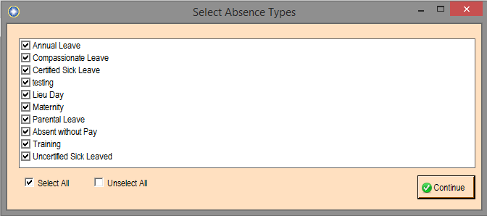

### Training Matrix Colours

When looking at the training matrix it is not always obvious which courses are due for renewal. We have added colours to the matrix to highlight those that need immediate attention.

If the course review date is:

* in the past - highlight the date in RED
* less than 7 days in the future - highlight the date in GREEN
* less than 28 days in the future - highlight the date in BLUE

### Assessment Scores Matrix

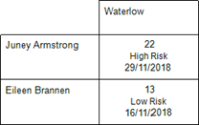We have adapted this printout so that it also includes the date of the assessment along with the score and the risk level.

### Custom Assessments

At the end of an assessment you can use either a default proposed action or type your own. This will now be printed at the proposed action at the top of the screen.

### About Me - Matrix Reports

When viewing residents ‘About Me’ assessments you have the ability to print a matrix that will allow you to see when they were last evaluated or when they are due for review.

### Resident Cashbook Balances

Print All Residents Balances Report now has a Grand Total at the end and the report is sorted by Surname then by First Name.

## CMS Desktop Changes

We have made the following changes, which originated from your suggestions on improving the CMS system. Your requests enable us to continually evolving the CMS system, thereby ensuring that your needs are always met.

### Scored Assessment – Display Previous Action

Residents > Assessment > Custom Assessments

When you review the assessment (review mode only) the user will be warned when:

* ‘Change in Risk Level’ – proposed action will also be updated with the new recommendation.
* ‘Risk Level Unchanged’ – previous proposed action will be used.

### Resident’s Medical History

Residents > Medical > Health

You can now attach medical history documents to a resident

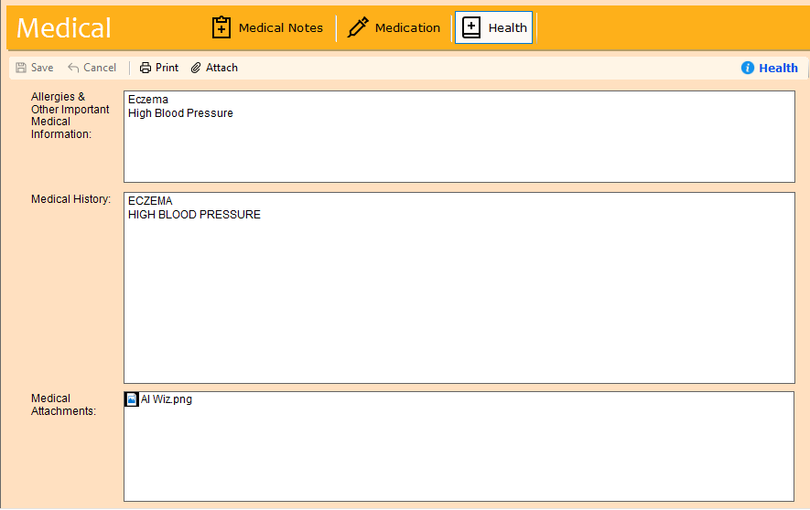

### Contacts – Additional Information and Labelling

Contacts now have 2 x telephone, mobile and email. Labels for telephone and mobile can be amended to suit your home.

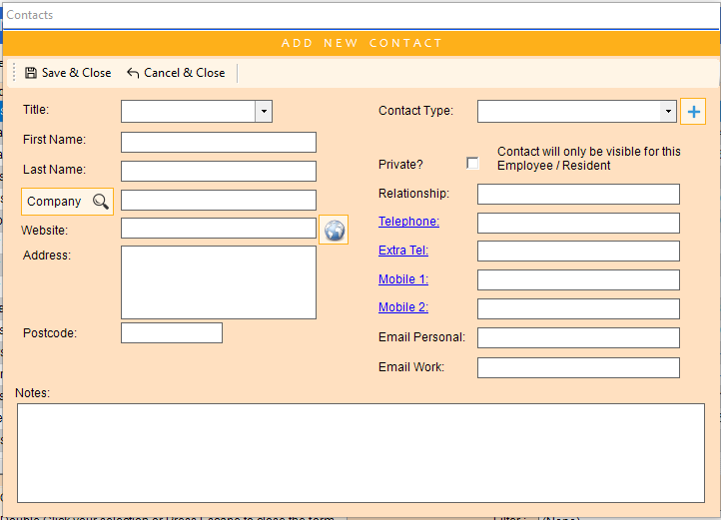

### Correspondence Email Attachments

Ability to save the attachment within the email

### Daily Notes – Attachment Notification Display

In Daily Notes if there is an attachment to the note, then a paperclip will display on the overview screen.

### Diary - Security Groups

Employees outside a security group can be communicated within the system.

### Diary – Legend Select Memory

Your selection choices for the legend will be saved.

### Filters – NOT Function

Where a field allows for criteria to be ‘=’, ‘<>’ will also be allowed.

### Resident / Employee – Report Packs

You can set up redefined report packs to print for an individual resident or employee. It previously allowed for a default pack only.

### Vitals View – Colour Coded

The vitals display is now colour coded so that all vitals recorded on one date appear with the same background colour.

## CMS Tablet App Changes

### Birthdays

We have added in the ability to highlight if it is one of your resident’s birthday on the tablet. When it is somebody’s birthday you will see a white birthday cake icon at the top of the screen. Tapping on this icon will display the screen below. The birthday cake will also appear next to the resident’s name along with their status flags

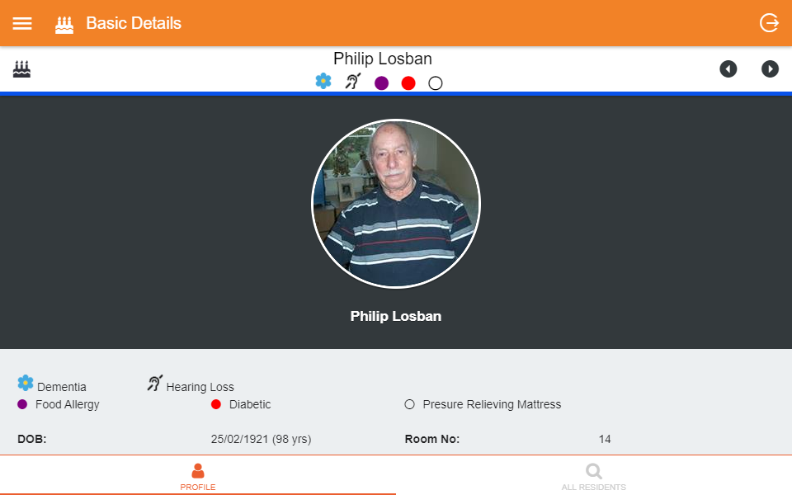

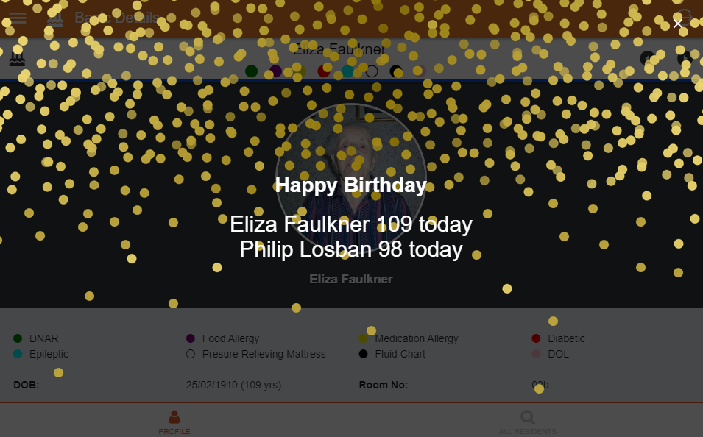

### Sorting

When searching for residents you can now sort them by either surname or room number. Simply tap on your choice. Your selection will be saved and set each time you access this screen.

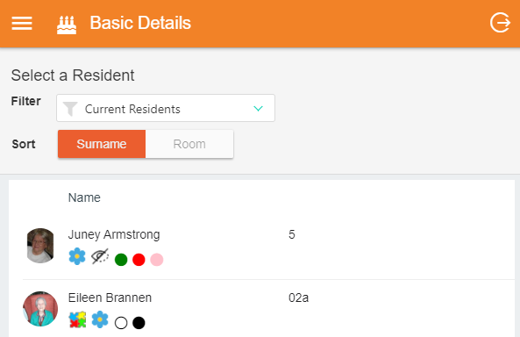

### Daily Care Filters

The ability to filter daily care notes has now been included. To filter the care notes, tap on the 3 vertical dots on the top right of the screen to display a menu and select filter. You can filter on the importance of a note and type in the search bar if you are looking for something specific. The search bar will compare against subject, logged by and the note itself.

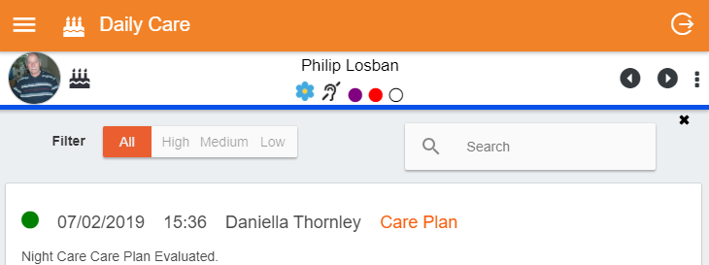

### AIS Signs

The AIS Signs which have been introduced in this update will also be included on the tablet. You will see them alongside all other status flags for the residents.

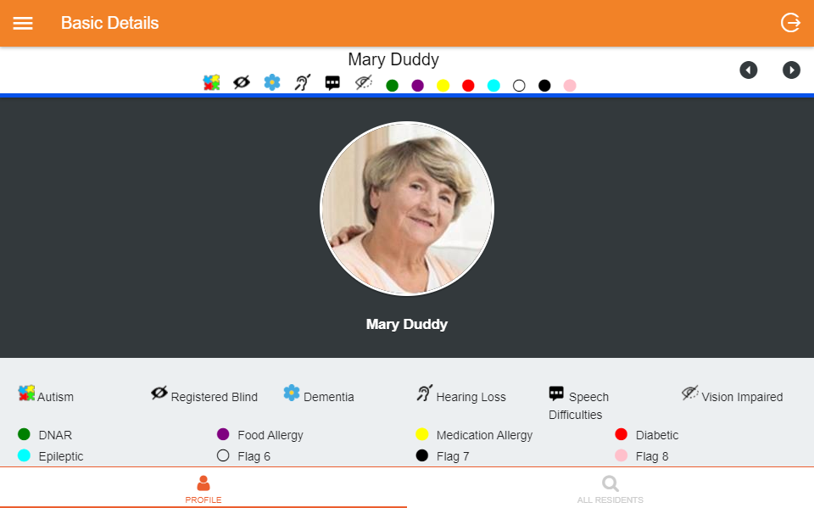

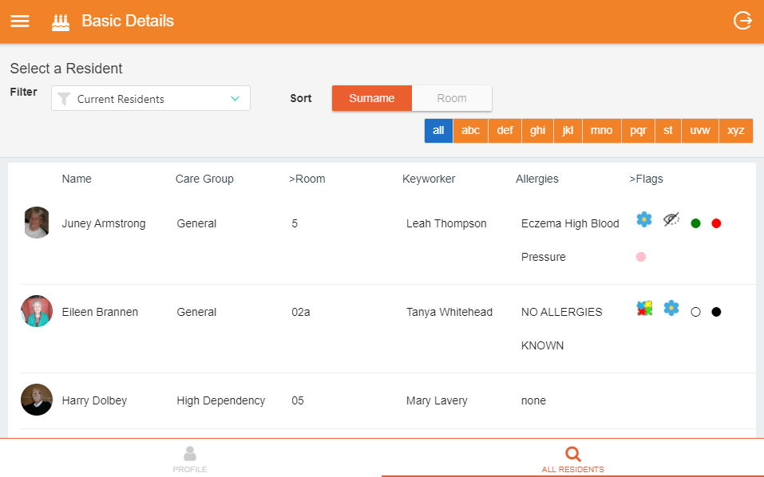

### Care Plan / Risk Assessment Previous Evaluations

We have added in the ability to be able to view previous evaluations of care plans and risk assessments. At the bottom of the page you will see a link that says ‘Previous Evaluations’. Tapping on this will bring back the last 5 evaluations for the care plan or risk assessment that you are looking at. This only works online so if you press the link whilst offline you will get a message pop up to alert you.

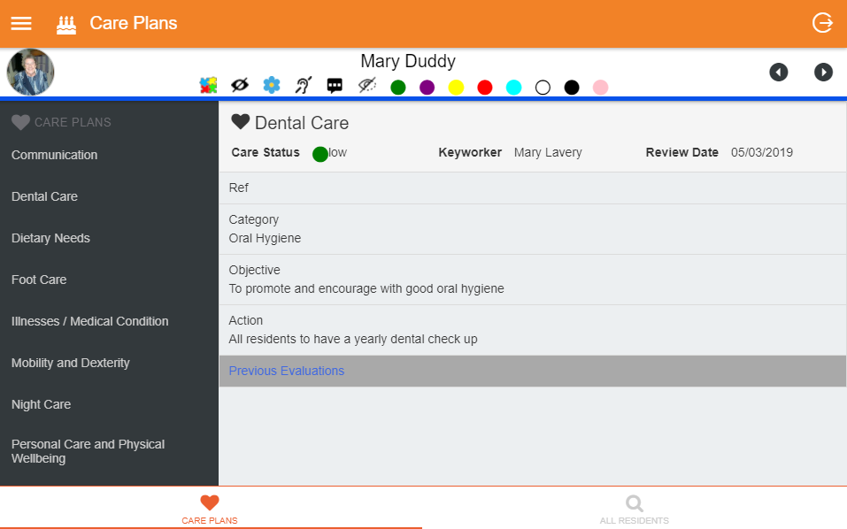

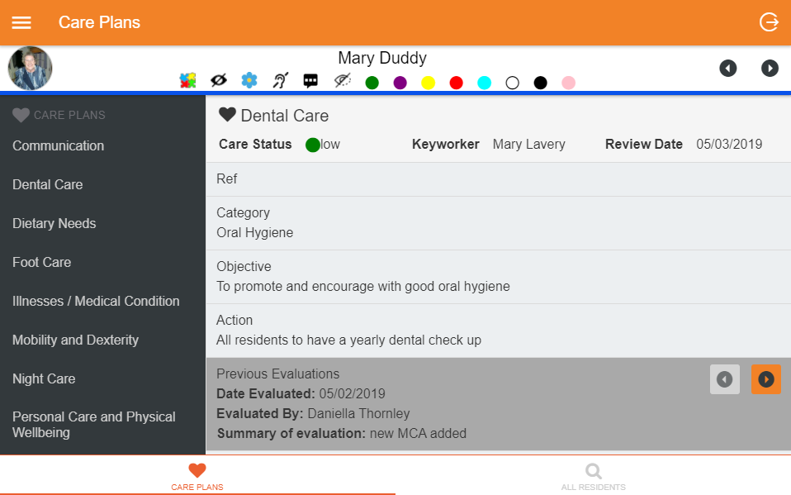

### Daily Care Emotion Mapping

Along with the addition of emotion mapping on the desktop and touch, you can also record a resident’s mood on the tablet when recording daily care notes or touch assessments.

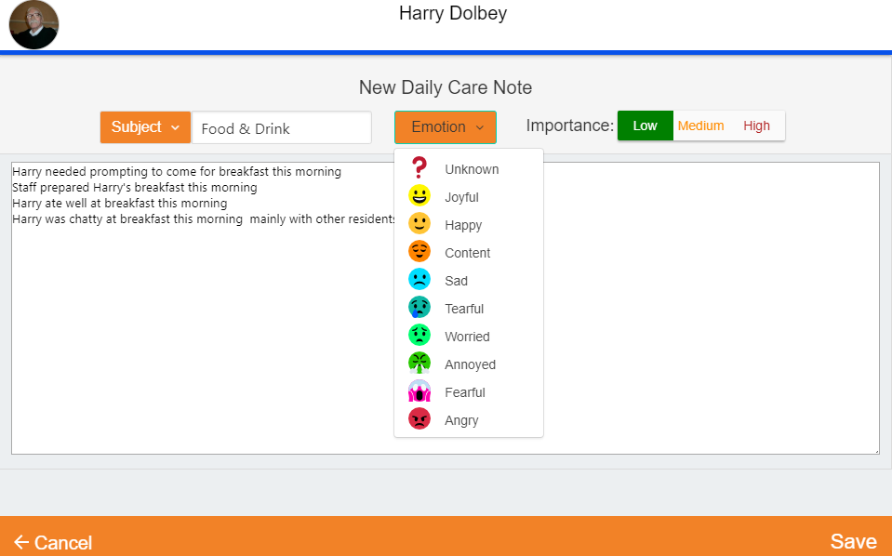

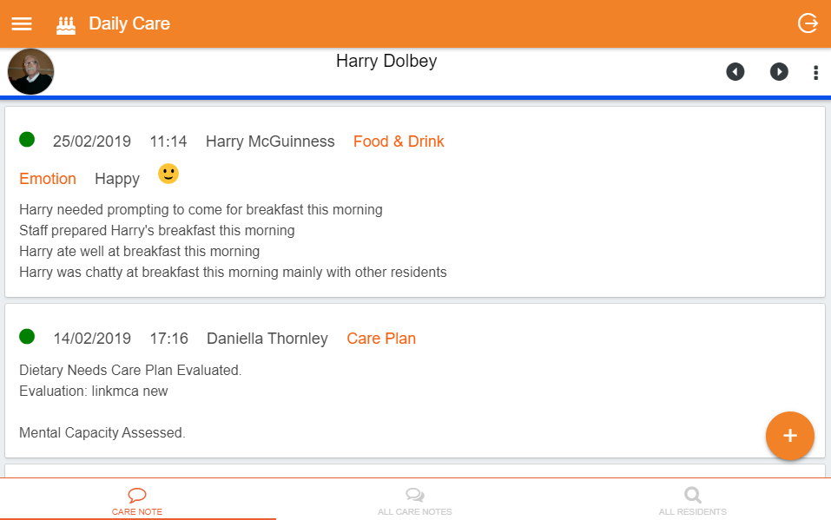

### Read Requests

A highly requested feature is now available on the tablet app - the ability to see read requests for a policy, care plan or risk assessment. In the case of a policy or form this can only be done through a message.

At the bottom of the message, if there is a read request attached, you will see a link to view the policy. Clicking on the link will then download the policy in a pdf format to the tablet. When you switch back to the tablet you will see a checkbox to confirm that you have read the policy.

When viewing read requests for care plans or risk assessments, you will see the same link however when you click the plan will appear as a pop up and you will be required to click confirm at the bottom of that screen.

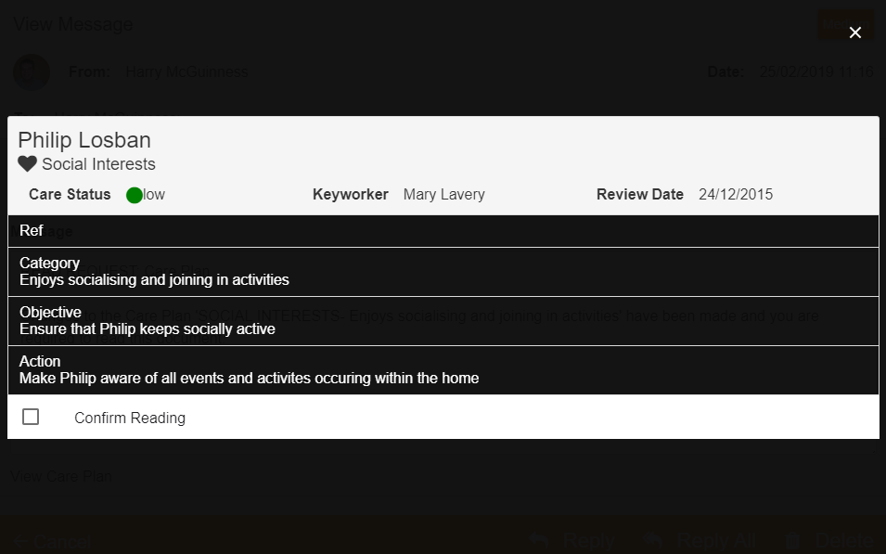

You can also head straight to the care plan section where you will see a label that says ‘Reading requested’ if a request has been made.

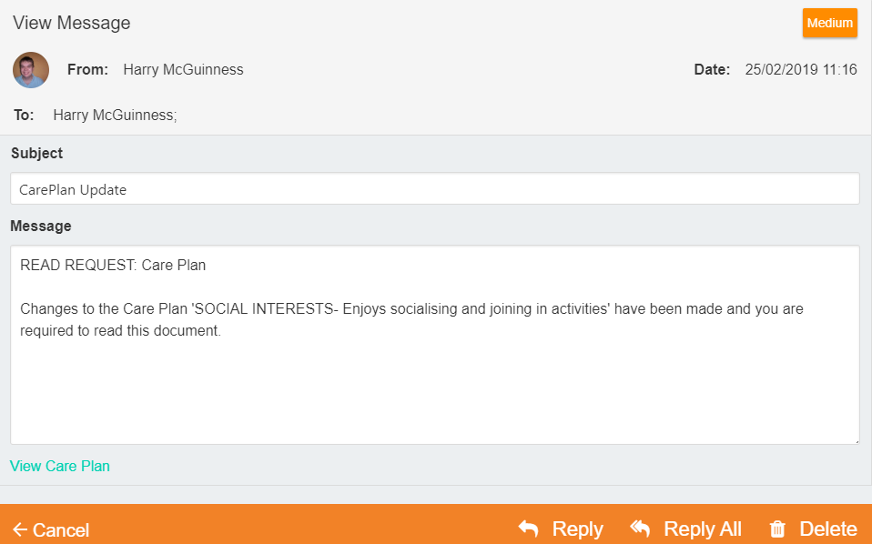

At the bottom of the plan will be the checkbox to confirm the reading.

