CMS

Release 7.2
Ablyss Systems
Email: support@ablyss.co.uk
Website: www.ablyss.co.uk

Ablyss Care Management System Release Notes
January 2020

Release Overview 3
Body Maps 4
Body Map Overview 5
Creams 7
Condition Follow-Ups 8
Body Maps and CMS Touch 9
Admission Snapshots 9
Body Map Links 10
Body Maps on CMS Tablet 10
Complaints and Suggestions 11
Details 12
Investigation 13
Actions 14
Security Settings 15
Reporting 15
Tasks 16
Task Performance 18
Useful Information 19
Audit Trail 19
Standardised Attachment Folders 20
Attachments Audit trail 20
Attachments Renaming File Type 21
Attachment Folders Naming Conventions 21
MCA Improvements 23
Ability to perform different MCA assessments. 23
Flow of the MCA screen & Final Decisions 24
CMS Desktop Changes 25
BMI for Amputees 25
Accidents and Incidents - Updating Care Records 26
Care Plan Text Formatting 27
Care Plan Importance Level 27
Care Plan Read Request Changes 28
Daily Care Emotions 28
Filter Positions 28
Archiving Employee Training 29
Training Reports 30
Quality of Life Updates 31
Adding Next of Kin 31
Employee Notes – Text Length 31
Employee Assessments 31
A & I Daily Care Entry 31
Residents Contact Details 32
Accidents & Incidents Time 32
Reports 33
Admissions Departures 33
About Me – Full and Summary reports 33
Changes to Templates setup 34
Assessments Report – Risk level 34
Bug Fixes: 35
Cost of Room Visible 35
Home Specific Labels 35
MCA Assessment Review Dates 36
Location Specific Templates 36
Daily Observation Contact Notes 36
Deletion of a Task’s Daily Care Assessment 36
Re-admission date 36
Accidents & Incidents Filters 36
CMS Touch 37
Ease of Use 37
CMS Tablet App Changes 39
1. Body Map Treatment Notes 39
2. Body Maps 40
3. New Body Map Conditions 41

Release Overview
The body maps have been completely rewritten to allow for the recording of creams as well as the introduction of body maps on the tablets. This will allow staff to add conditions / treatment notes at the point of care including the option to take a photo with the handheld devices to upload directly to CMS.

A complaints and suggestions area can be found under the Home module alongside the Accidents & Incidents. This will allow you to keep track of received complaints and resolve them before the need of a 3rd party.

The release comprises of the following: -
- Body Map Redesign
- Complaints & Suggestions
- Further MCA Improvements
- Task
- Resident / Employee Attachments
- Tablet Pre-admissions
- Tablet Body Map
- Employee Training Archiving
- Care Plan Font Improvements
- Minor Enhancements
  - Reports
  - Desktop
  - Touch
  - Tablet

Body Maps

The Body Maps module has been redeveloped to provide you with greater flexibility. We had also received requests to implement the body maps on the tablet devices.

We took this opportunity to redesign the body maps to improve the way that you record conditions and to introduce a cream chart. Finally, a ‘Body Map Admissions’ will allow you to take snapshots of the current body map allowing for documentation of before/after hospital admissions.

One of the most requested changes was to add more diagrams to the body map, to include Head, Hands, Feet and Oral, in addition to this we have separated the front and back and introduced a side profile.

Key Points
- Body Maps now allow for a Cream chart
- Body Map admissions to create a snapshot of all Body Map Conditions
- Additional Diagrams to record conditions on
- Link a Custom Assessment to a body map condition
- Predefined locations linked to diagrams

Body Map Overview

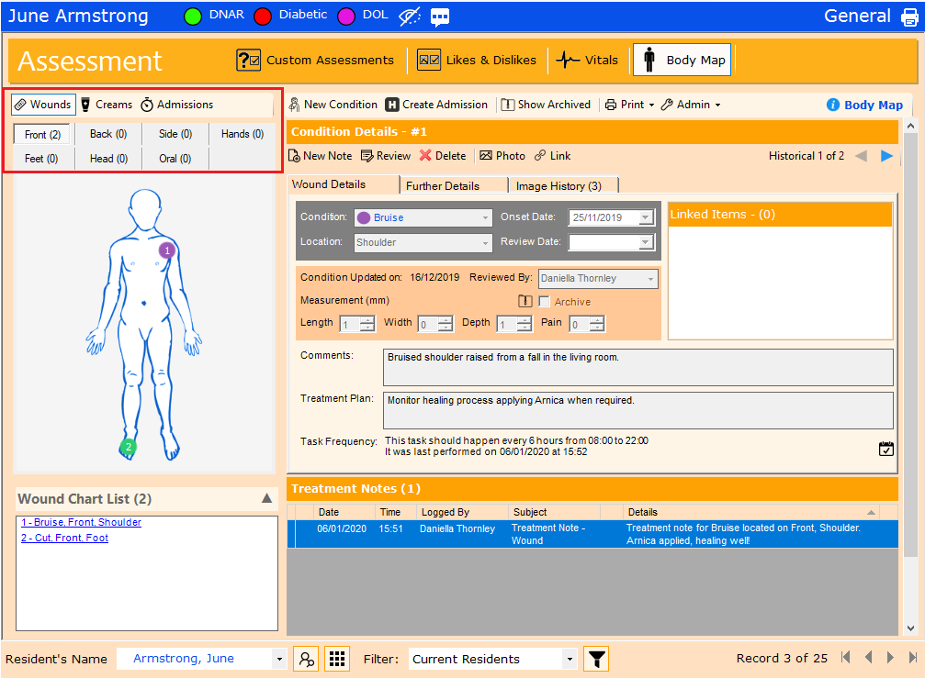

The body map now allows for wounds (previously a condition), creams and admissions. Although we haven’t made any changes to the conditions, a new feature that has been introduced is the ability to link a Custom Assessment to a body map condition. A different assessment can be set against each specific condition allowing for full customisation. For example, you could have an assessment to be performed after a new pressure sore has been located and an assessment upon recording a burn. This can be viewed on the “Further details” tab.

Each diagram has a list of predefined locations for example, when adding a condition to the persons Front, you will be able to choose from one of the following: Bicep, Chest, Foot, Forearm, Hand, Head, Knee, Pelvis, Shin, Stomach or Thigh. You can alter and add to these lists by going to ‘Admin > Locations’ in the toolbar. This secondary location will be used to identify individual conditions when reviewing or writing treatment notes from the shift handover.

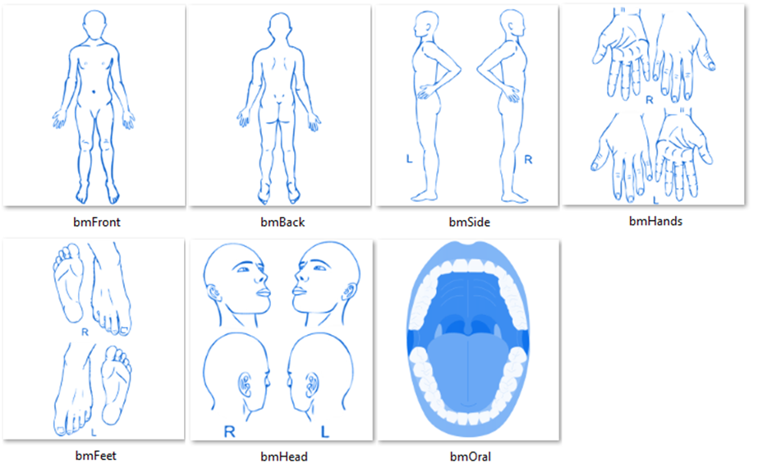
Against each diagram will be a number indicating how many conditions are displayed on each tab, as highlighted above.

Creams

When adding a Cream, after clicking ‘New’ a red highlighted box will appear to allow you to indicate where the cream is to be applied. You can drag and drop this box to move it to the affected area and resize it by using the sizing handles, any time you are creating or editing a cream, it will be highlighted by this red background.  Once saved the cream area will turn green indicating it has been saved. When you are viewing a cream, the colour will be purple to indicate the current highlighted cream.  You can alter the creams frequency list by going to ‘Admin > Cream Frequencies’ in the toolbar | 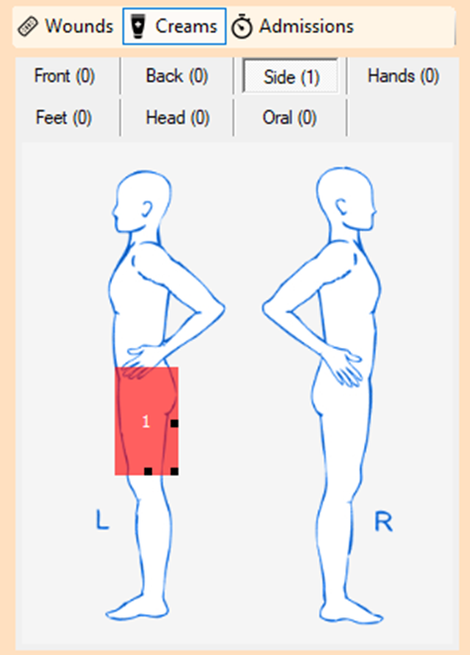

Condition Follow-Ups
We have integrated the tasks feature into the body maps, whilst you are looking at a specific condition you are able to set up a task that will alert users to perform a treatment note, this will be available for conditions for activities such as redressing a wound or to set a cream frequency that will alert staff when a cream is to be applied.
When adding a treatment note from a task you will use a new form (shown below), at the point of writing a treatment note you are able to attach a/multiple photo’s, this expands on the previous body map which only allowed one photo per review. The details about the cream/ condition will be disabled as these should only be updated in a Review. Any time a task has been completed, the treatment notes will be displayed in the daily care and against the body map entry they have been written for.
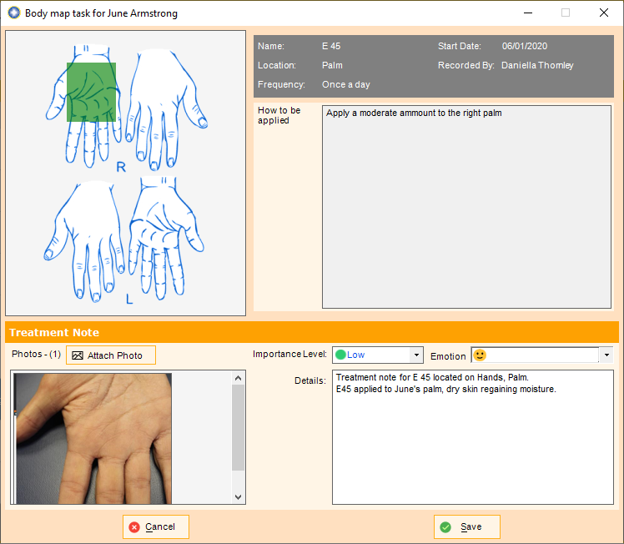

All of the condition’s photos can then be viewed on the Image History tab when looking at the body map, again a number will display the total number of photo’s attached to this condition. When viewed you can see the progress of the condition with the dates of when the images were taken.
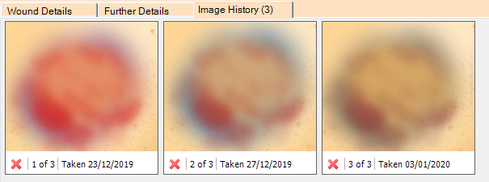

Body Maps and CMS Touch
Although the ability to add body maps has not been introduced to the touch system, because you can now set up tasks within CMS, you have the ability to record treatment notes on CMS Touch using the Body map form shown above.

Admission Snapshots
Snapshots allow you to keep an archive of a “current body map” state, allowing you to see the conditions present when a resident is admitted to hospital, so that when they return, you can identify which conditions may have happened whilst outside of your care. When viewing a snapshot, you will only see the review current at the time of the snapshot.
To create a new admission, click the: button, after a prompt CMS will confirm that a snapshot has been taken, please note, you may only take one snapshot per day.

Body Map Links
When you add a condition e.g. a pressure sore, you may want to attach relevant documentation to the issue. Links allow you to associate a combination of Custom assessments, Risk Assessments, Care plans or other body map conditions to the current body map record. For example, you can link a resident’s pressure sore to a cream chart and a ‘maintaining skin integrity’ care plan.
When viewing a document that has linked records you have the option to access or even review that document.

Body Maps on CMS Tablet
Body maps have been added to the tablets!
One of the primary benefits this brings is the ability to write body map entries at the point of care. As the carers identify new conditions, they are able to add a record to the body map, complete with photo’s if necessary straight from the tablet’s camera or gallery. Read more in the Tablet release notes below.

Complaints and Suggestions

One of the new modules that we have created is designed to help you log, investigate and respond to any complaints / Suggestions / concerns made. Complaints can be logged against individual residents, employees or against the home in general.
To begin using this new module please go to: Home > A&I > Complaints / Suggestions
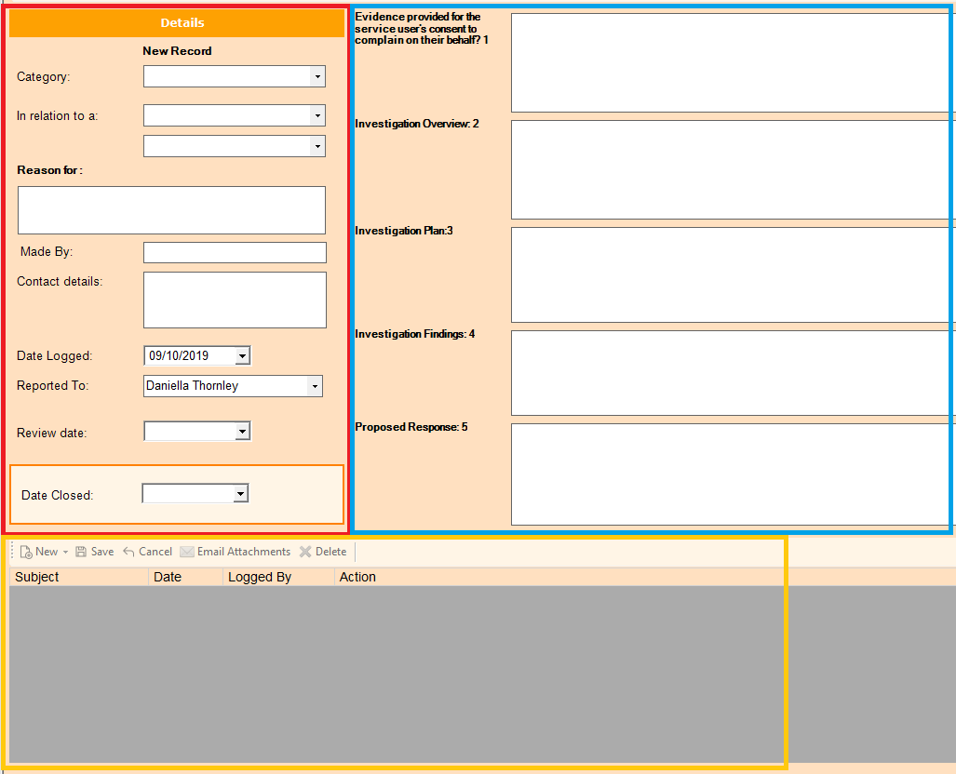
- The screen has 3 main areas, firstly, on the left we have the details of the feedback itself:
- The right side contains the investigation details of the feedback
- The bottom keeps a record of all actions made against the current feedback.

Details
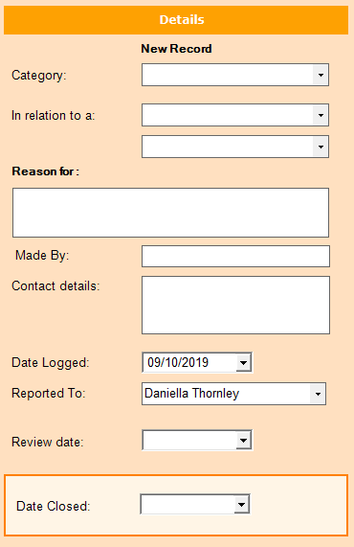 | Category: You are able to distinguish between complaints, suggestions or concerns.  Relation: State whether the complaint is against a Resident, Employee or the home. You can also state, if applicable, who the complaint is against.  Reason for: The basis of the complaint  Made By / Contact details: Details of who complained and how the home can contact and respond to them.  Date & Reported To: When the complaint was added to CMS and also who uploaded the data  Date Closed: Setting a date here will archive the complaint. Archived complaints are no longer displayed in the default list.

Investigation
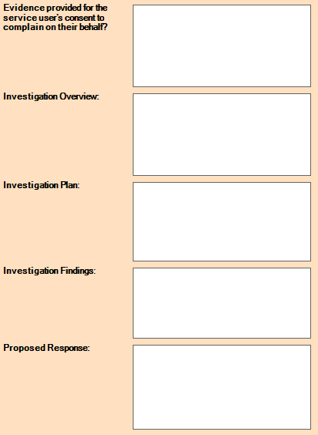 | These labels can be changed by going to Admin > Change Label Descriptions.  These textboxes are to include information on the complaint. How you will investigate issues raised, what issues were found and how you will resolve them.

Actions
You will also be able to attach your own complaint template documents by going to Admin > Setup Complaint Templates. Once set up in here they can be accessed when adding a new complaint note at the bottom of the screen.
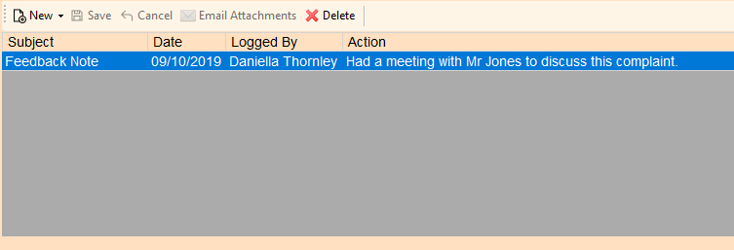
The notes area will allow you to write quick notes as the investigation into the complaint progresses. When you send a template letter, a note will be saved into the actions grid with a link to the attachment. Once you have added and made any changes to the document you can highlight which letter you wish to send and click ‘Email attachments’, If you have CMS set that you can send emails, you will be able to send an email straight from this record.

When feedback is due to be reviewed it will be displayed on both the shift handover and the home dairy. Anyone with access to view Complaints will be able to see these reminders and clicking one will open the complaints form to the record so the user is able to review.
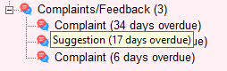

Security Settings
To manage the access rights of who can view this feature, we have added a new security setting in the Home module so that you may control who can access to the Complaints / Feedback area. After first updating CMS users will be able to view the complaints module if they are able to view the Home A&I. This will mean if you wish to start using this area you will need to go to: Admin > Security > User Profiles so that you can assign who has the access to view and add new records.

Reporting

Individual Complaint
This report will print all details about the report the user is currently viewing. You will also have the option to print this same report but for all unresolved complaints.

Tasks

We have redesigned some of the underlying functionality of the tasks, to help improve performance and to offer the following new features:
- Addition of weekly events to the Task Frequency
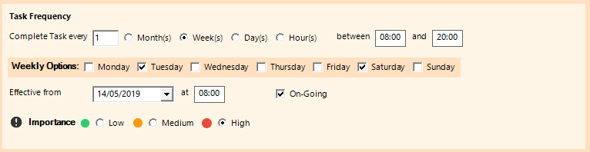

- Addition of specific days on the month for the Task Frequency. Select between
  - The same day for each month
  - A specific event each month, such as the first day or the second Monday
  - A month after the last task was performed (default value prior to version 7.2)
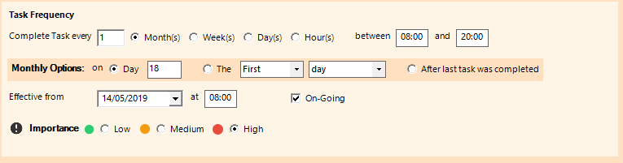

- Ability to assign multiple residents to one task. Traditionally you either needed to create a separate task for each resident or create a task based on a filter such as ground floor.
- Ensure that Specific Resident is selected from the Resident Group
- Click Add / Remove Residents to select your residents
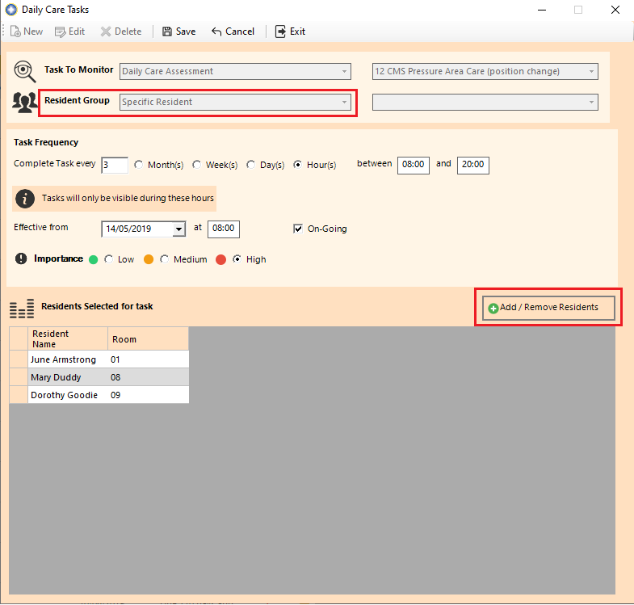

- Assigning Tasks to Body Map wounds and Creams. You must be within the Body Map module to create a new task however when in the Task Admin screen, you will be able to all tasks assigned to an individual resident

Task Performance

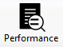
A new feature, Task Performance, has been added. This feature is accessible from the Task Screen in the main CMS Desktop

The purpose of this feature is to help inform you how regularly tasks are being missed. Enter a date range (this will default to the last day) and click calculate. By default, any missed tasks within this date range will be shown, however you can change your focus by increasing the number of missed tasks to be displayed. In this example only tasks which have been missed twice or more consecutively are displayed.
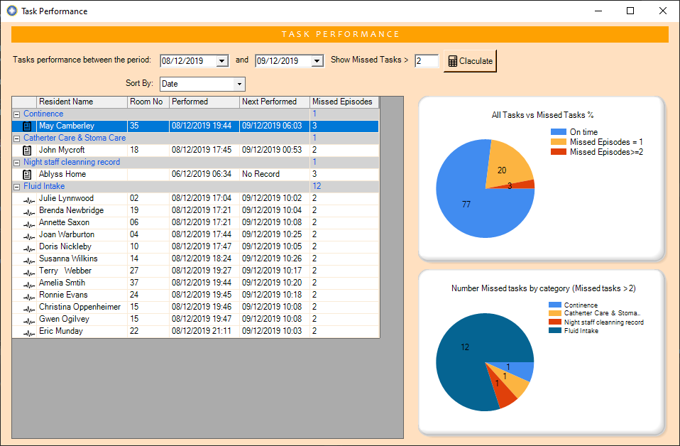

Useful Information
 | Hover you mouse over the icon to display details about the task. For example, this task should happen every day between 08:00 and 20:00.
Hourly Tasks | If a task is set to perform say every 4 hours, a task will be classified as missed if it is more than 20% of the time frame overdue. So, if a task is due every 4 hours, it would be flagged as missed if it has not performed in the first 48 minutes of its due date.
Next Performed | - Date – If a date is displayed this is the date the task was next performed after the Performed Date  - No Record – No record could be found of this task being performed within the date range specified  - Outstanding – The task is still outstanding and due now.

Audit Trail
An audit trail has now been added for the creation, amendment and deletion of tasks.

Standardised Attachment Folders

It has been requested that users can add a specific set of folders into each residents / employees Attachments folder. We have added a ‘Folder Templates’ structure to allow you to do this.
To access this feature, when looking at a Residents or Employees attachment, click on “Admin > Setup folder templates”.
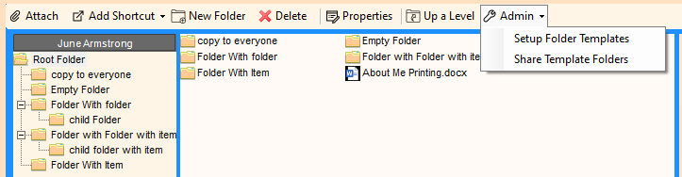
When you are setting up the templates, the screen will be highlighted by a blue border. When you return back to somebody’s attachments, this will return to normal.
To copy the current set of templates to other records, click ‘Admin > Share Template Folders’ CMS will then cycle through all current records, check their attachments folder for each parent folder in the templates folder, if it can’t find a match it will copy over everything in the folder.
This will also allow you to copy Files as well as folders.

Attachments Audit trail
We have added in the capability for CMS to track changes within the Docstore when it is altered through CMS.
CMS will now track:
- When a file has been Added / Deleted.
- When a File/Folder has been renamed
- When a file/folder has been copied to the clipboard

Attachments Renaming File Type
We have also changed the renaming of files in CMS so that users are no longer able to change the extension of a file. For example you are no longer able to rename a “.Docx” document to “.txt” however you can still change the name of the document.

Attachment Folders Naming Conventions
Windows reserves various folder names for its own use. One that people have been having issues with is ‘PRN’. We have added a check so that if you are trying to rename a folder and you choose one of these reserved folders you will now get a message telling you so and will be able to rename it before it will cause an error.
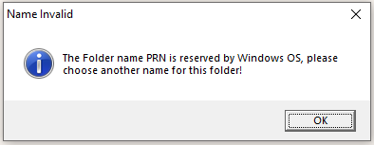
The full list of reserved folders. is as follows: CON, PRN, AUX, NUL, COM1, COM2, COM3, COM4, COM5, COM6, COM7, COM8, COM9, LPT1, LPT2, LPT3, LPT4, LPT5, LPT6, LPT7, LPT8, and LPT9
Please note that a folder called ‘Resident PRN’ will cause no issues with the windows naming system.

MCA Improvements

In 7.1 we introduced the new MCA area. We have received feedback on how we can improve this further, these are the changes we have made.

Ability to perform different MCA assessments.
The MCA is designed to have one Assessment linked to each record. This assessment was to be the same across all assessments. We had received requests for the ability to have a number of different assessments depending on the category of the assessment, for example the assessment for financial capacity can differ to the assessment for personal hygiene.
Now when you have selected ‘Yes’ that you believe there to be an impairment of the brain or mind you can select from the drop down a list of MCA assessments which one you would like to be carried out alongside this MCA.
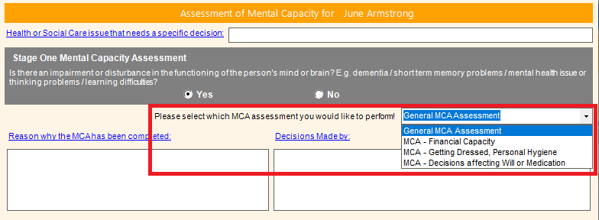
To add more assessments, click the ‘Admin’ button in the MCA toolbar. The Assessment wizard is the same as used when creating Residents or Touch assessments. You can also reposition the assessments and set a ‘Default’ Assessment by moving it to the top of the MCA assessments list.

Flow of the MCA screen & Final Decisions
We have adapted the MCA’s so that they take the user through as more of a step by step process. When they first open a new MCA they are displayed with Stage one.
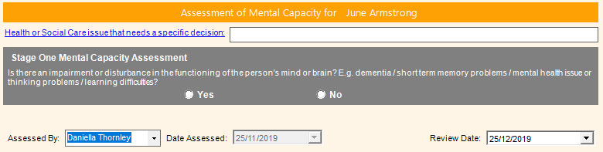
Once making a selection CMS will provide the ‘Comments’ and ‘Decision Makers’ fields and if you have selected yes, the MCA assessment combo box will also be displayed.

After filling out the assessment you will be brought back to the summary screen to make any final changes. We have also added a ‘Summary of Final Decision’ Textbox. So that when you come to review the MCA you can easily see the outcome of the initial/previous assessments.

CMS Desktop Changes

We have made the following changes, which originated from your suggestions on improving the CMS system. Your requests enable us to continually evolving the CMS system, thereby ensuring that your needs are always met.

BMI for Amputees
A new feature that has been added is an extra data field when recording data on a resident, the ‘Missing Body Mass’ this is to be used where the resident is an amputee and will be used when calculating the BMI on the vitals. When editing a resident’s basic details beneath the weight will be this new field. If you click on the icon, CMS will display the recommended values to use for different types of amputation as estimated by the Amputee Coalition. Please note that these are only estimated values and you can adjust according to the severity of the amputation.
To calculate the BMI simply add a weight and CMS will take into account any missing body mass the resident has and calculate their correct BMI.

Accidents and Incidents - Updating Care Records
We have added the ability upon completing an Accident / Incident report to update an existing care plan or if no relevant documents exist, you can create a new one. On the final page of an A&I report you will see a list of the residents Care plans & Risk assessments. Simply choose any that you with to review/update in relation to this Incident & click finish.
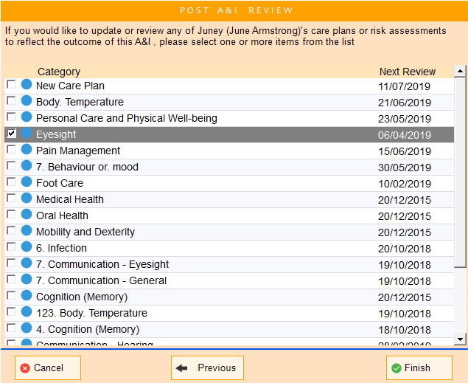

Care Plan Text Formatting
Many people have requested that we add the ability to use text features such as the ability to colour, bold, underline & highlight text within the care plans & risk assessments. When editing / reviewing a care plan you will see a font toolbar at the top of the screen.
1 2 3 4 5 6
- Bold 5. Highlight Text
- Italic 6. Add bullet points
- Underline 7. Hyperlinks
- Text Colour

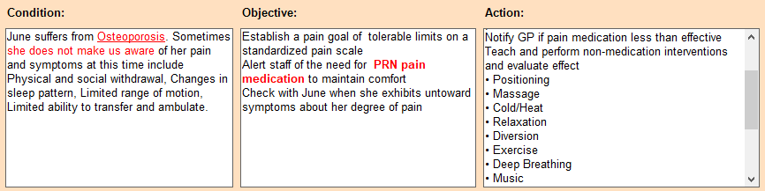
These extra formatting options will be displayed when printing the report.

Care Plan Importance Level
When adding a new evaluation after clicking save, CMS will ask for a daily care importance value, you are now able to close this using the ‘X’ and continue to update the care plan.
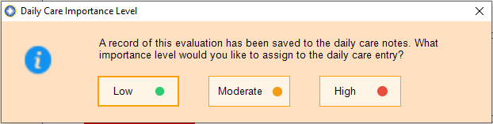

Care Plan Read Request Changes
In CMS anyone can request users read a care plan or risk assessment. This caused problems when someone who doesn’t have access to see all read receipts wanted to check on who had read their read request for the updated record.
Our resolution to this is to allow those users who have requested a record be read is the ability to access the reading report for the requests that they have themselves requested.
Whereas any user that has ‘Admin’
access to the care plans or risk assessments can view all of the read requests (as is with current versions of CMS).

Daily Care Emotions
Last release we introduced an emotion status in the daily care. We have added 2 more status, these are:
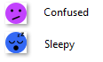

Filter Positions
We have added the ability to order the resident / employee filters. When you click the filter button to edit filters you will see a Up/Down arrow. Highlight the filter you want to move and using the up/down arrows position it where you would like it, finally close this screen and the position will be remembered. This will order the list for all staff. Please note any ‘Private’ filters will always be placed below the ‘Public’ filters.

Archiving Employee Training
As users have added training records over the years, a lot of the older records have become irrelevant, this is why we have introduced this feature that will allow you to archive training records. To archive a record simply check the Archive record checkbox when editing training.
To view archived training simply click the button in the toolbar.
Archived training will be displayed in the list and will be displayed with the archived icon used elsewhere in CMS:
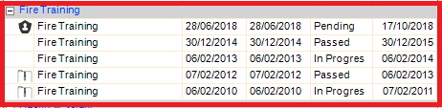
As you can see first record in the list is specified as mandatory, with 2 Un archived training records and 2 archived training records. If you archive all training records in the category, the category will no longer be displayed.
Show Archived:
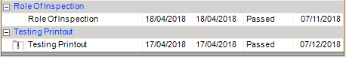

Hide Archived: The whole ‘Testing Printout’ record is hidden
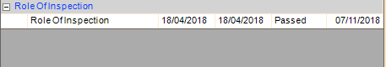

Training Reports
The training matrix has been adapted so that it will only print archived data if the user has selected to show archived. This will allow you to hide any training records that are no longer relevant.

Quality of Life Updates

Adding Next of Kin
When adding a new contact, if the contact type is either ‘NOK’ or ‘Next of Kin’ CMS will automatically default them to a Private Contact. This will ensure that the contact can only be seen from the Resident / Employee record they were created against/Linked to.
This will not affect any existing Next of Kin contact records.

Employee Notes – Text Length
Employee notes character limit removed, previously capped at 500 characters.

Employee Assessments
When filling out employee assessments you were stopped from visiting other areas of the system, It has been requested that we disable this restriction so that when adding things like Employee Sickness forms you can access the Absences to ensure you fill out the assessment correctly.

A & I Daily Care Entry
There is a setting used to specify whether you would like to log all Accidents & incident entries to the resident’s daily care. Originally having this checked would automatically check the ‘Write to daily care’ when filling out a A&I record however the user could uncheck this and no record would be saved in the daily care. We have changed how this button functions so that now, if it is checked, the note will
always be written to daily care, and if not, the note will not be written to daily unless specified when creating the individual A&I record.
This setting can be found here:
Tools > Settings > Module Settings > Accidents & Incidents

Residents Contact Details
The residents contact details have been converted into a full contact, allowing you to save a full detail of their contact information.
The Residents mobile number has been added to the basic screen to be displayed with the contact details.

Accidents & Incidents Time
When entering a time on accidents and incidents, the user can now also use a drop down box filled with times in 15 min increments.

Reports

Admissions Departures
We have changed the admissions and departures report to include a checkbox to show whether a notification has been sent to your regulating body.
We have also fixed a bug where if you had changed the ‘Regulation issued’ label, the changed value was not being used when looking at the departures screen.

The resident reports will now show the status flags in the summary at the top of the first page printed.

About Me – Full and Summary reports
When printing About me records CMS was only able to print the summarised versions of the assessment reports. This has been changed so that when clicking print you will be able to choose a Full Assessment or a Summary.
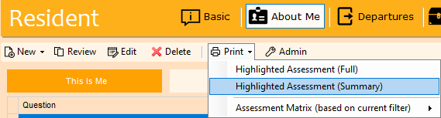

Changes to Templates setup
In CMS you are able to set up correspondence templates, currently when adding a new template CMS will create a blank word document for you to build your own document. Now when adding a new template, CMS will allow you the ability to link and already existing document. This will speed up the process when adding new templates.

- When writing an accident /incident, you can now select a time from a drop-down box, this increases in 15-minute intervals.
- Daily care notes, Vital recording & A&I can no longer have their time occurred set to the future.
- When printing a scored assessment, the risk level was being cut off after ~15 characters, this has been resolved.

Assessments Report – Risk level
When printing a scored assessment, the risk level was being cut off after 15 characters. This has been resolved and the text will use all the space available.

Bug Fixes:

Cost of Room Visible
If you have Resident Admin rights, when viewing a Resident’s record, on the ‘Admission Details’ screen you can view the room Admin screen by clicking the blue + symbol. In the room admin grid, CMS displayed the cost of each room. We have changed the access to this ‘Cost’ field so that to view it you must also need Administration View rights under the Admin module.
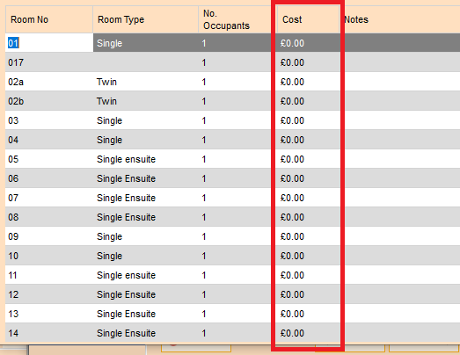

Home Specific Labels
Fixed a bug where renamed labels were not being picked up by CMS and were instead using the default text.

MCA Assessment Review Dates
The MCA assessment was using the system default review dates and not the MCA Assessment specific review dates set when the Custom assessment was created.

Location Specific Templates
For customers that use CMS in a multi home environment, when setting templates to show in specific locations there was a bug that stopped CMS from reading which locations, they belong in. This has been resolved in this version.

Daily Observation Contact Notes
If a user that does not have access to view medical notes, looks at the daily care they were unable to view daily care notes that were linked to a non-medical contact. This has been resolved so that only notes linked to medical contacts will be obscured.

Deletion of a Task’s Daily Care Assessment
When you deleted a daily care assessment that had a Task linked to it, the task would be kept and the assessment linked would state “Model unknown”. The task will now be removed if its corresponding Assessment is deleted.

Re-admission date
When readmitting someone that had left the home, you were able to enter a readmission date before the date the resident had left. You will now encounter an error message alerting you when trying to do this.

Accidents & Incidents Filters
Last update we made changes to the Types & Categories so that are interlinked. A bug has been fixed that wouldn’t allow you to select a Category when trying to create a new filter to filter on incident category.

CMS Touch

Ease of Use
If you have been logged into CMS and have used the alphabetical filters at the top of the screen, if you log out and a different user logs in, CMS will automatically filter back to ‘All’. This was due to tasks being missed if the logged-on user didn’t realise the list was being filtered from a previous user’s filters. If you log out and back into the same account, CMS will remember your last used filter allowing you quick access to where you left off.

CMS Tablet App Changes

Body Map Treatment Notes
Ability to add treatment notes for the body map, either via tasks or via the new body map menu option.

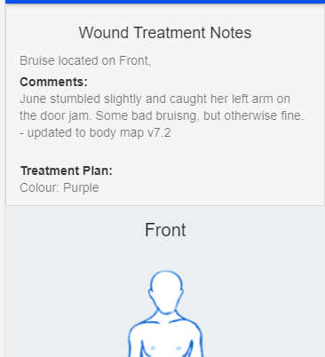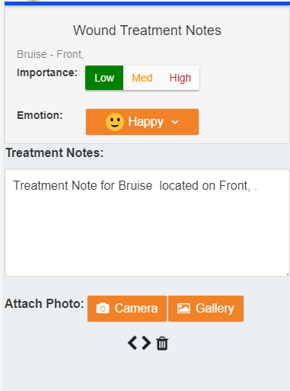

Multiple photos can be attached to the treatment note.

Body Map Overview
Additional menu option for Residents, namely body Maps
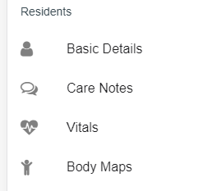

This will give you a list of all the current Wounds and Creams and allow you to add either treatment notes to an existing condition or capture a new condition.
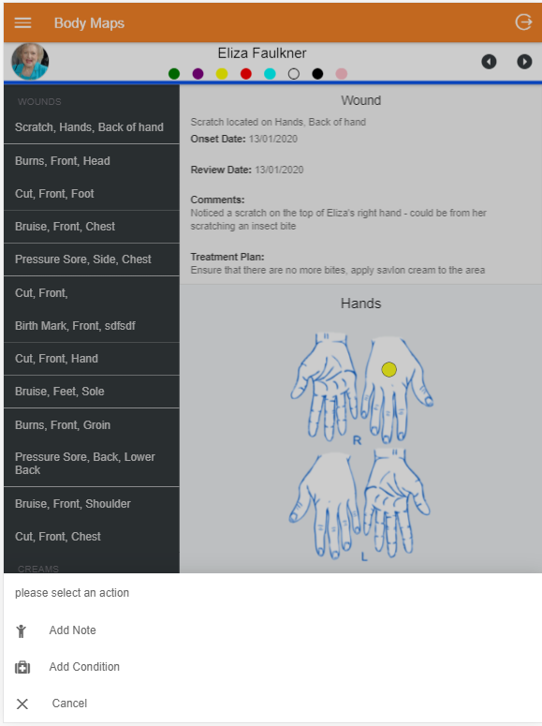

New Body Map Conditions
Entering a new condition is as simple as selection the Location, selection the condition and inputting the position, then clicking on the diagram where the condition is located.
Enter some comments, the treatment plan will automatically update with ‘Treatment Plan to be confirmed’, attach the photos – then save.

